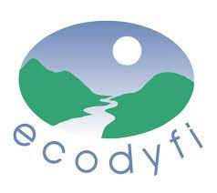
Resources for improving home energy-efficiency
A resource pack created by Ecodyfi in the interests of improving the energy-efficiency of buildings
in the Dyfi Biosphere area - to lower emissions and enhance wellbeing.
Community Energy Wales Videos / Fideos Ynni Cymunedol Cymru: 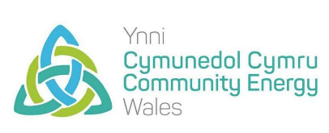
Energy Efficiency Masterclass
https://www.youtube.com/watch?v=MehL5F5BV-E&list=PLUPhCRR-GVXUcrm2g5ypBwoJ7kdtya0i9
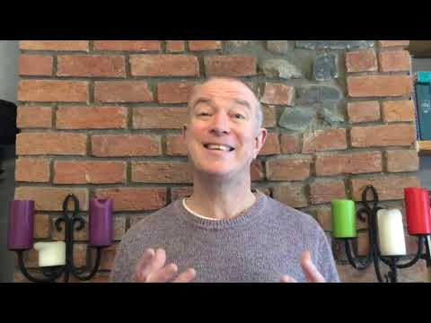
Videos include:
1. Initial essentials – Not the easy fix!
2. Whole house approach
3. The 4 C's of moisture
4. PAS2035
5. Myths and pitfalls
6. Devil in the details
7. Understanding your building
8. Future demands of building
9. Embodied carbon in retrofit
10. Practical examples and a How to do it guide
11. Community involvement

A link to a video from Historic Environment Scotland about Retrofit: https://www.youtube.com/watch?v=2ZKPiiLa9DE

Advice and Information:
CAT (Centre for Alternative Technology) offer free advice on eco-renovation, energy choices, and many other relevant topics: https://cat.org.uk/info-resources/free-information-service/ Residents of SY19 and SY20 postcodes get free entry to CAT. There are also eco-refurbishment short courses for much more detailed practical advice (for a fee).
Cartrefi Clyd – a directory of support towards home energy-efficiency in Wales: https://www.cartreficlyd.cymru/
Energy Saving Trust has guides on draught-proofing, insulation, energy suppliers, and more: https://energysavingtrust.org.uk/energy-at-home/
Big Energy Saving Network – information and advice to help manage your energy bills: https://www.citizensadvice.org.uk/about-us/our-work/our-campaigns/all-our-current-campaigns/besw/ Freya is our local BESN contact: freya@ecodyfi.cymru
Powys Energy Advice Service: https://www.powyscitizensadvice.org.uk/services/v/3-energy-efficiency/
Severn Wye Energy Agency’s ‘Energy Advocates’ help Powys residents make sure they are heating and powering their homes affordably. Use the form at https://severnwye.org.uk/project/advocate-powys/ to ask them to call you.
Home Energy Advice pilot for those on low incomes in Gwynedd and Ceredigion: https://www.warmwales.org.uk/home-energy-advice-pilot/
STBA (Sustainable Traditional Buildings Alliance) Whole House Approach: guides us towards retrofit that considers the building’s inhabitants, structure, history, and context: https://stbauk.org/whole-house-approach/
PAS 2035 provides specification for the energy retrofit of domestic buildings, and details best practice guidance for domestic retrofit projects: https://www.trustmark.org.uk/ourservices/pas-2035
The Optimised Retrofit project is making over 1,724 homes in Wales more energy-efficient, by providing them with a ‘Pathway to Zero’ and taking the first step on this pathway: https://sero.group/optimised-retrofit/
CITB ‘Building Skills for Net Zero’ research report - https://www.citb.co.uk/about-citb/construction-industry-research-reports/search-our-construction-industry-research-reports/building-skills-for-net-zero/
Cosy Homes - “a one-stop home retrofit service, making it simple to make energy efficiency improvements to homes in Oxfordshire” - https://cosyhomesoxfordshire.org/
Retrofit Works – a not-for-profit cooperative aiming to lower energy bills, create healthy homes and achieve Net Zero - https://retrofitworks.co.uk
TheGreenAge – practical advice on saving energy. Including clear summaries of different options available, and tutorial videos: https://www.thegreenage.co.uk/
Funding
The Green Homes Grant has ended and was only for England. The Green Deal has also ended, but that's still circulating on social media too.
The Energy Company Obligation (ECO) is a government energy efficiency scheme to help reduce carbon emissions and tackle fuel poverty. ECO 4 is the current round of funding. It can be used for installing insulation or upgrading heating systems.
ECO4 Flex is worth investigating - especially if you're off the gas grid - note that EnergyGrants is a private sector installer, not an impartial provider of advice.
ECO4 Flex is managed by your local authority e.g. https://en.powys.gov.uk/article/13370/Scheme-to-help-tackle-fuel-poverty-approved.
In Powys the scheme is administered by https://www.warmwales.org.uk/powys-energy-saving-scheme-2/.
Gwynedd https://www.gwynedd.llyw.cymru/en/Residents/Housing/Energy-in-the-home/ECO.aspx.
Ceredigion opens 21st November 2022 https://www.ceredigion.gov.uk/resident/housing/financial-assistance/energy-efficiency-schemes/eco-flexibility-funding/.

Powys residents can access interest-free loans up to £10,000 for home improvement through Robert Owen Community Banking: https://www.rocbf.co.uk/home_loans_mid_wales/

Welsh Government’s NEST scheme offers a range of free, impartial advice and, if you are eligible, a package of free home energy efficiency improvements such as a new boiler, central heating, insulation, solar panels or a heat pump. Their friendly advisors can offer free and impartial advice on:
- Saving energy and water
- Money management
- Making sure you’re on the best energy and water tariff
- Whether you are entitled to any benefits to boost your income
Call Freephone 0808 808 2244
https://nest.gov.wales/?gclid=Cj0KCQjwldKmBhCCARIsAP-0rfxDLzCRioA7f8gQvpHo93bXgldxAv_s2z6B5o4jyb59K7P3tl2RGvgaAiIBEALw_wcB

Borrow a thermal camera
Ecodyfi has two FLIR One infrared thermal cameras you can borrow for free. These attach to a smartphone and can show where heat escapes from your home. This is most effective when the weather is cold and you have heated your house.
See more information and the link to the booking calendar here: www.ecodyfi.wales/climateaction
Contact andy@ecodyfi.cymru to arrange borrowing a thermal camera.
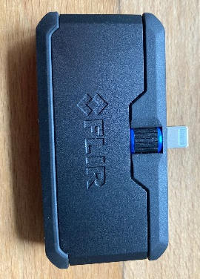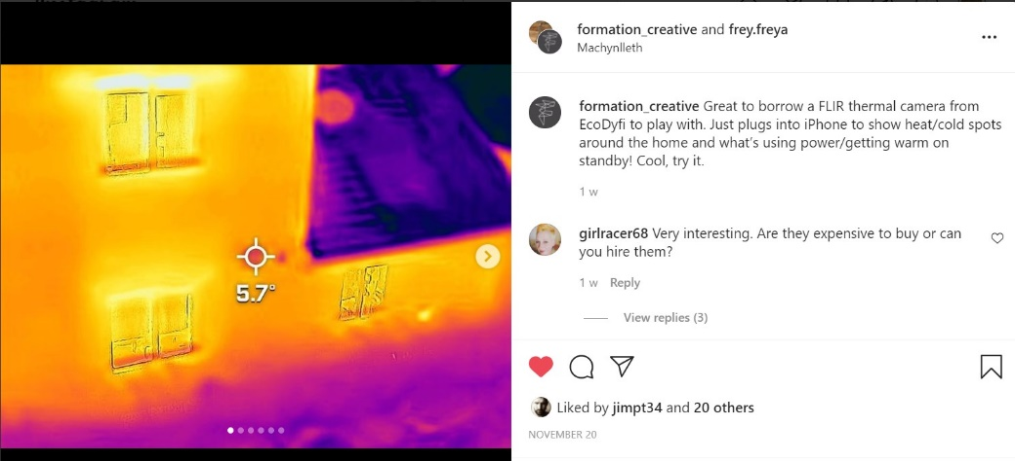
Where to go for tradespeople:
Trustmark www.trustmark.org.uk/homeowners/find-a-tradesperson
Trade bodies https://www.fmb.org.uk/
Builders who do insulation work: https://aecb.net/directory-members/
Local word of mouth / Local social media recommendations e.g. https://nextdoor.co.uk/ , ask around in your community to see which tradespeople others recommend
Local Housing Association
For installers of energy options such as heat pumps or solar PV: https://mcscertified.com/find-an-installer/
~~~~~~~~~~~~~~~~~~~~~~~~~~~~~~~~~~~~~~~~~~~~~~~~~~~~~~~~~~~~~~~~~~~~~~~~~~~~~~~~~~~~~~~~~
If you know of other links and resources people may find helpful, or have other comments about www.ecodyfi.wales/climateaction please contact andy@ecodyfi.cymru. August 2023

