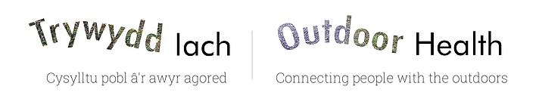
Trywydd Iach Project
Evaluation Report
Year 1 2021-2022
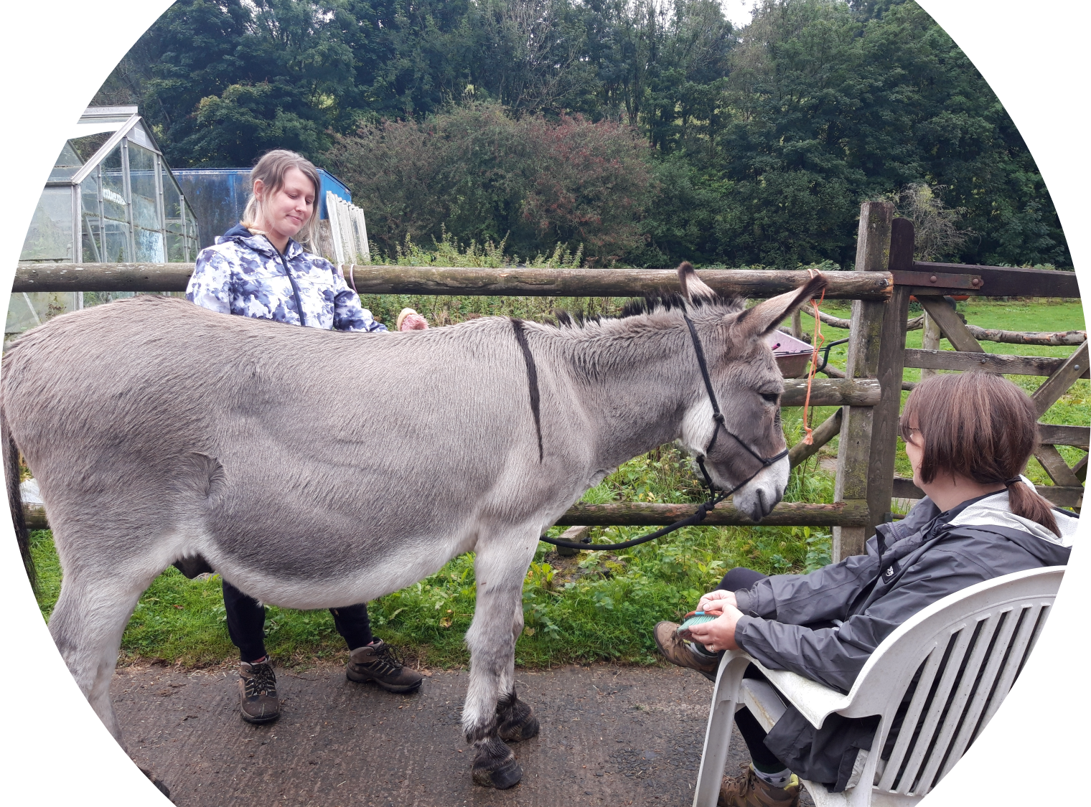

“Being out in nature, sitting around the fire doing the mindfulness sessions. The tension just seem to leave me. Being with likeminded people, no one seemed to judge or worry either and it felt good”
(Participant, Ynys-Hir Woodland Activity Session)
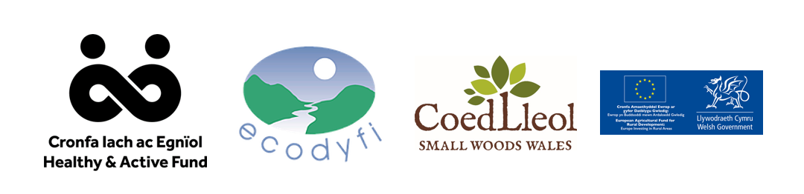

Contents
Background 3
Part 1 – Trywydd Iach: Social Prescribing to Outdoor Health 5
Introduction 5
Year One Outputs: Social Prescribing 7
Referrals 8
The Participants 9
Health Issues 10
Evaluation 11
Methodology 11
Mental Wellbeing Benefits 12
Physical Health Benefits 13
Overall Health Benefits 14
Nature Connection and Woodland Contact 14
5-ways to Wellbeing Measures 15
Inspiring changes in participants 16
Improved mental wellbeing 17
Social Wellbeing 17
Improved Physical Health 17
Increased Confidence 18
Connection to nature 18
Provided Inspiration & Motivation 18
Improvements 19
Overall Rating 19
Part 2 – Trywydd Iach: Healthy Travel 21
Year One Outputs: Healthy Travel 21
Outcomes year one: Healthy Travel 21
Recommendations from the Community Consultation events 22
Barriers 23
Comments from Participants 23
Secondary School Consultation 24
Healthy Travel Board 24
Working in partnership 24
New proposals for cycling and or walking routes 25
Training sessions 25
Areas of improvement 25
Conclusions – Year One Trywydd Iach Project 26

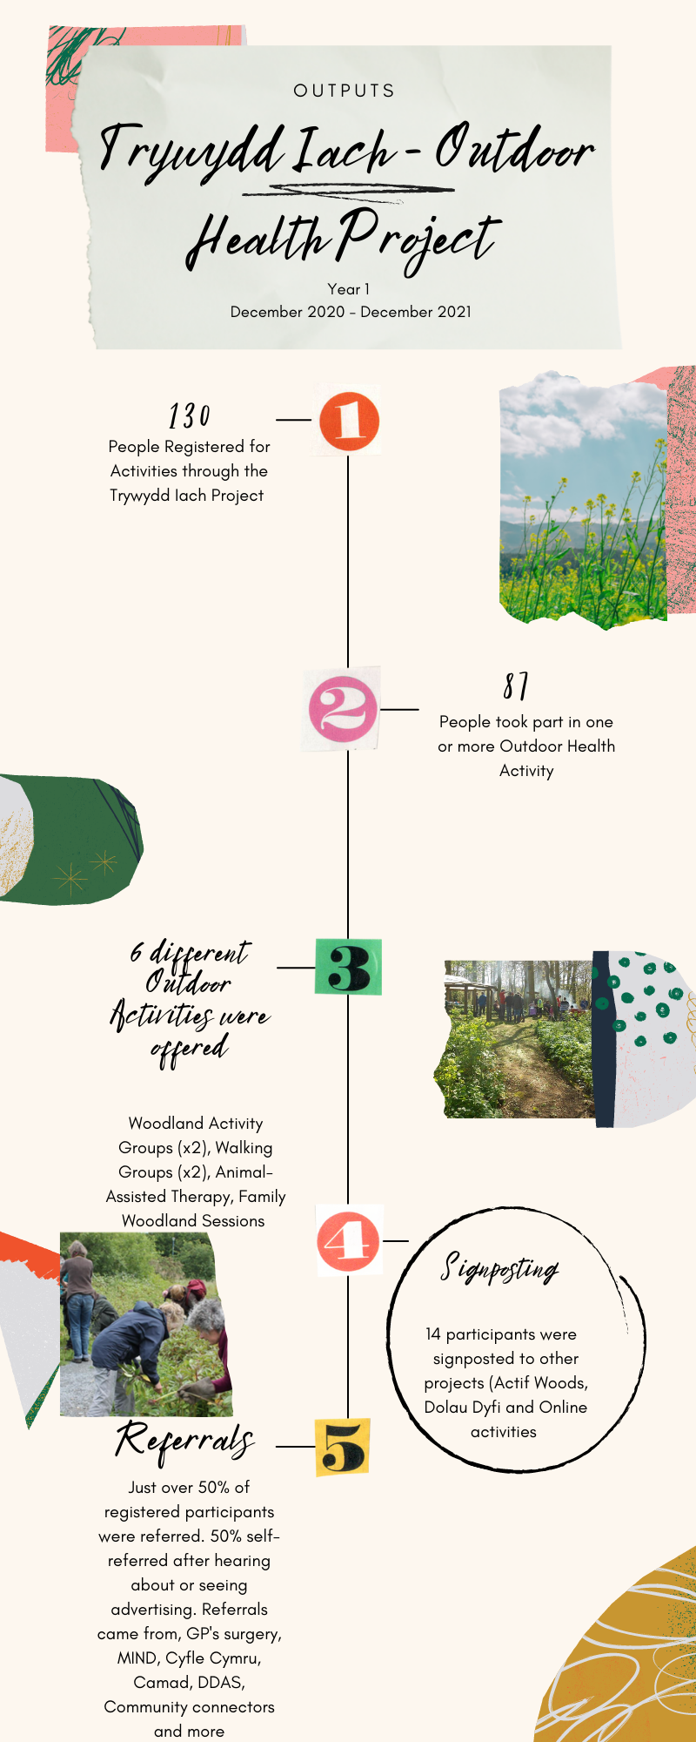
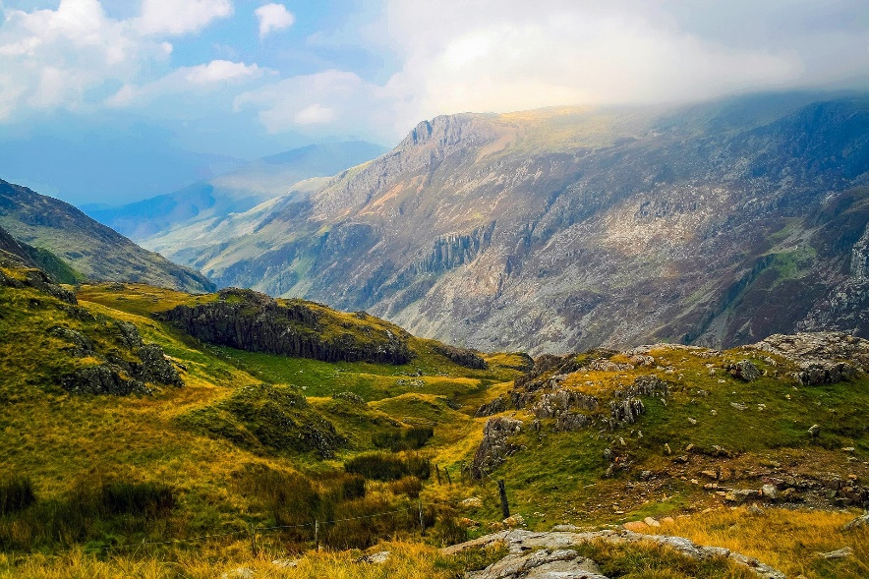

Background
There is a growing body of evidence that demonstrates that outdoor nature-based activity can improve mental health, increase lifespans, and reduce the incidence of chronic disease. Currently, it is estimated that only a quarter of the population in Wales participate regularly in outdoor recreation and 47% are active for fewer than 150 minutes per week. The NHS report that one in four people will experience mental health issues at some point in their lives. The rise in mental and physical health issues are putting additional stress on GPs and the NHS, with an estimated 20% of all GP appointments concerning social rather than medical health issues.
In Wales, it is recognised that despite the first-class natural resources to hand many people are not accessing them regularly, and opportunities for social prescribing to outdoor health activities in some areas were minimal or uncoordinated. Moreover, although several independent agencies and charities offer outdoor health and wellbeing activities there was no joined-up network (or partnership) that could link them to healthcare providers to explore and ensure best practice across this sector and embed social prescribing more fully to encompass outdoor health and wellbeing.
Social prescribing to Outdoor Health (or ‘Green Social Prescribing’) has been gaining ground and recognition in Wales (All Wales Social Prescribing Network). There is a need to streamline the process, offering a wider choice of outdoor activities for all abilities, and developing a joined-up system for registration, monitoring and evaluation thus addressing some of the challenges that were identified from research. Social prescribing to outdoor health can play a role in supporting people to engage with outdoor activities to address social isolation, some mental and physical health conditions whilst also acting as a preventative health measure.

Barriers for Health Professionals | Barriers for Participants
- A lack of knowledge about the benefits  - A lack of knowledge about what activities are available and when (short or long term)  - A lack of confidence over the governance, cost-benefit and (health) training of providers | - Social Anxiety  - Transport  - The need for one place to access all  - Concerns over access in the outdoors (accessible pathways, seating, toilets, parking)
Key barriers to participation identified in consultation with health professionals and the community
In 2019, Coed Lleol – Small Woods Wales worked in partnership with EcoDyfi on a short pilot project to develop a system to promote and support social prescribing to outdoor health in the Dyfi Valley area. Follow-on funding has developed this project into Trywydd Iach – Outdoor Health Project working to connect people to outdoor activities in this area.
During the pilot, consultation was undertaken that highlighted the need for greater levels of connectivity across the area so that residents can access areas safely on foot or by bicycle. The Trywydd Iach project responded to this with the launch of the ‘Healthy Travel Project’. This aims to progress the initial consultation with key stakeholders to establish potential safe healthy travel routes within the Dyfi Valley Area.
Part one of this report will cover the outputs and outcomes of year one of the Trywydd Iach – Social prescribing to outdoor health and part two will explore the key achievements of the Trywydd-Iach – Healthy Travel

Part 1 – Trywydd Iach: Social Prescribing to Outdoor Health

Introduction
Trywydd Iach (The Outdoor Health Network) has addressed the challenges by developing a single point of entry for 6 different outdoor health activities that are accessible to the communities of the Dyfi Valley (see map below).
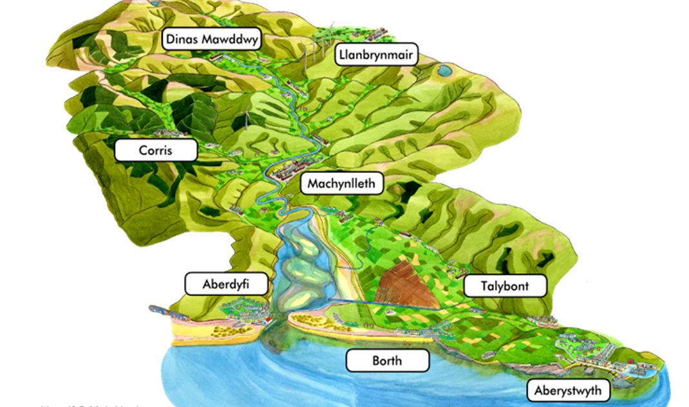
Map of Dyfi Valley/Biosphere Area
The project also developed a referral system where people in need can either be referred directly by their GP surgery, link, or support worker to the project for a consultation and subsequent registration to suitable activities. Alternatively, people can refer themselves to the project, thereby providing the potential to take pressure off public services which are already under great strain (see diagram below). In response to the initial evaluation, continuous delivery and signposting have been encouraged for participants who need longer-term support to engage and access the outdoors. So far, the project has established referral links with 4 GP surgeries as well as Mental Health Charities and community and link workers. Although there is a long way to go to embed this practice more fully into the health sector across Wales this project provides valuable learning that has been the catalyst for roll-out to three other Welsh Regions (Rhondda Cynon Taf, Pembrokeshire and Gwynedd).
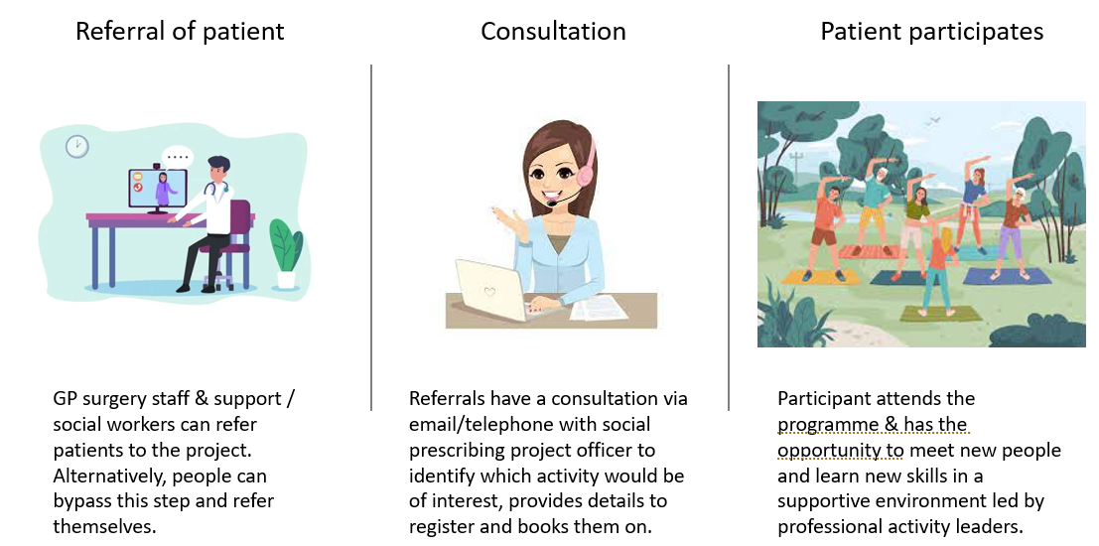
Trywydd Iach – Outdoor Health Network process for referral

Year One Outputs: Social Prescribing
The Trywydd Iach project has registered 139 people and engaged 87 participants (78 adults and 9 children) in one or more activity from April 2021-January 2022. December-March was recruitment, training, and set-up, delivery was delayed due to Government Lockdown January-March 2021). Despite the late start, the project was just under it’s target of 100 participants per annum.
During May 2021-December 2021 the project has delivered the following,
Type of Session | Number of Sessions | Number of participants
Walking Group – Machynlleth (Every Friday – Friendly Walkers from the surgery) | 31 | 14
Walking Group – Aberystwyth | 31 | 20
Woodland Wellbeing Activity Sessions - Ynyshir | 15  (9 summer sessions, 6 Autumn sessions) | 18
Woodland Wellbeing Activity Sessions - Ynysmaengwyn | 6 | 10
Woodland Wellbeing Activity Sessions – Family Sessions | 10  (5 November sessions, 5 December sessions) | 17  (8 adult and 9 children)
Animal Assisted Therapy – Dyfi Donkeys | 14  (7 Summer sessions, 7 Autumn sessions) | 15
Additional Sessions – due to demand
Follow-on Animal Assisted Therapy Sessions | 8 | 11
Follow-on monthly woodland sessions | 5 | 13
Totals | 120 | 87  (excluding double counted participants who attended more than one activity)

The ongoing evaluation highlighted the need for continued support for participants to support mental wellbeing and physical health longer-term. Both the group setting and the support of the group provided was seen as an essential part of engagement for many of the participants. The Trywydd Iach project were able to provide a series of follow-on activities in the form of a bi-weekly Animal Assisted Therapy group and monthly Woodland Activity group to support this need. Additionally, one participant’ has been active in setting up a ‘participant-led – project supported’ peer support monthly group. These actions provide a valuable model for the project going forwards.

Referrals
The project in year one had just under 50% referred participants and just over 50% of participants who self-referred (after hearing about or seeing posters/advertising/social media about the project). The referrals came from the following health services,
Referral type | Number of participants referred | Number who engaged
Church Surgery Aberywstwyth | 6 | 2
Machynlleth Surgery | 3 | 3
Tywyn Health Centre
Unspecified NHS/GP referral | 3 | 2
Mind | 8 | 8
Camad | 2 | 1
CMHT | 1 | 1
DDAS | 4 | 4 (Actif woods Ceredigion)
Mental Health Services | 2 | 2 (Actif Woods Signpost)
PAVO | 1 | 1
Cyfle Cymru | 1 | 1
Treherne Care group
Cerrig Cornel Care home | 2 | 2
Ceredigion community connector | 2 | 1
Powys community connector | 1 | 0
Hywel Dda
Tan-y-maen | 1 | 1
Age Cymru
Social worker /support worker | 3 | 3
Eco-Dyfi Pilot/Dolau Dyfi | 3 | 3 (Path Maintenance)
TOTAL Referred | 43 People | 49% Referred
Participants who self-referred heard about Trywydd Iach – Outdoor Health in several ways as shown in the chart below,

The Participants

78% of participants in year 1 were female, 20% male and 2% did not state their gender

The participants came from the following Welsh Index of Multiple Deprivation areas and urban-rural contexts,
42% live in E2 – Rural village in a sparse setting
38% live in D2 - Rural: Town and Fringe in a Sparse Setting
14% live in C2 - Urban: City and Town in a Sparse Setting

22% of participants live in WIMD 1-5 (most deprived)
78% of participants live in WIMD 6-10 (least deprived)

Health Issues
The participants self-declared health issues are shown in the chart below. 75% self-declared health issues at registration (some may have had health issues that were not declared) .Most participants listed mental health issues – depression, anxiety and stress (32%) or longer-term mental health conditions (5%) many had multiple physical and mental health conditions (21%).

The participants had a range of health issues that demonstrate that the Trywydd Iach network was able to connect people with health needs to the outdoor activities. In comparison, data from Coed Lleol (Woodland Wellbeing) shows that 50% of participants self-declared health issues, indicating that the cluster approach is more able to attract an engage those with health needs.

Evaluation
57% of the participants returned evaluation forms. This provided a good basis for understanding the reception to, and impacts of, the Trywydd Iach Programmes.

Methodology
A pre-and post-survey method was utilised to measure changes in participants physical health and mental wellbeing. Surveys could be completed with an online link, on paper or over the phone.
The three validated measures that were used in the pre-and post-surveys were;
- The Warwick Edinburgh Mental Wellbeing Scale (WEMWBS) was used to measure the impact on wellbeing

- The International Physical Activity Questionnaire (IPAQ) was used to measure changes in physical activity

- The EQ-5D-5L health thermometer was used to measure self-perceived changes in overall health
The results of each are presented in the following section.

Mental Wellbeing Benefits
The Warwick Edinburgh Mental Wellbeing Scale (WEMWBS) was used to calculate the overall wellbeing scores for the participants. This utilises a two-week recall, self-report, wellbeing indication using a 5-point scale on fourteen set wellbeing indicators. Wider research across the UK using this method has found that the average wellbeing score for adults is 51 points (out of a possible 70 points). A point score change of three or above is considered a ‘meaningful change’ in wellbeing. The Participants completed a WEMWBS test before starting the programme and then completed the same test once the programme had finished.
39 participants so far have completed both pre-and post- WEMWBS. The mean score for wellbeing rose from 43 (out of a possible 70) to 47, showing that the activities that the Trywydd Iach programme provided were able to contribute to increased wellbeing across the cohort. Taken on an individual level 77% of the participants who completed both the pre-and-post-WEMWBS evidenced increased wellbeing. 64% showed a significant change of above 3 points.
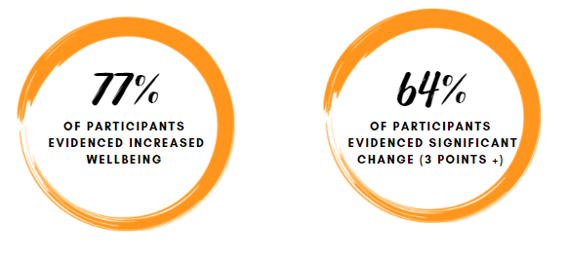
“The biggest change in me is to my mood and mental health. Having a session to look forward to each week adds both structure and hope to my days. Being amongst other like-minded people ensures I don't feel too isolated, which is a constant issue for me as I live alone and experience severe depression and anxiety. The fact that everything is planned, there is no pressure on participants, and everyone understands the issues we are all struggling with means it feels like a genuinely safe space, and perhaps the only times in my week when I can genuinely relax and feel like I have nothing to worry about”

Physical Health Benefits
Physical health changes were measured using the short version of the International Physical Activity Questionnaire (IPAQ). IPAQ uses a self-report, 7-day recall, of the amount and duration of vigorous, moderate and walking exercise that a participant recalls from the previous week. The scores are converted into an overall MET score that provides an indicator of weekly physical activity. To calculate change, individual scores are converted into a single MET score that provides an indicator of weekly physical activity. A high MET score of over 1500 indicates a high level of physical activity, a MET score of between 600-1500 indicates a moderate level of physical activity and a MET score of under 600 indicates a low level of physical activity.
32 of the participants completed both pre-and post- IPAQ questionnaires. The average mean rose from 3080 MET points to 3746 MET points (an overall increase of 666 MET points). Taken individually, 50% of the participants evidenced increased MET scores, 3% showed no change and 47% evidenced a decrease in physical activity.
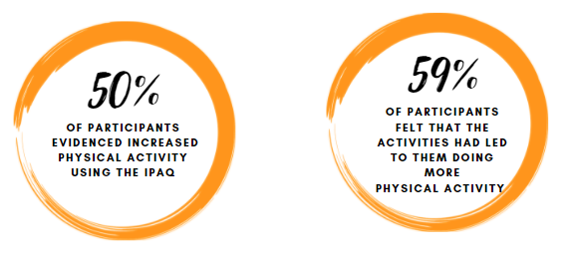
“I've been extremely inactive throughout Covid so this project has helped to gently ease me back into more physical activity again, and I find myself spending more time in my own garden working. I always have more energy on the days I am able to participate in these sessions”
(Trywydd Iach Participant)

Overall Health Benefits
Overall health was measured using the ‘health thermometer’ from the EQ-5D-5L where participants were invited to state how good or bad they felt their health was on that specific day. The participants were shown a 0-100 scale, where 0 was ‘the worst health that they could imagine’ and 100 was the ‘best health they could imagine. 32 of the participants successfully completed both pre-and post- EQ-5D-5L health thermometers. Mean scores rose from 59 to 72 (an increase of 13 points). Taken on an individual level, 66% of those showed increased, self-declared, levels of overall health from the start of the programme to the end of the programme.
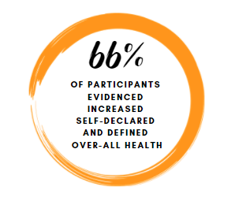

Nature Connection and Woodland Contact
The Trywydd Iach activities aim to encourage the greater use of outdoor green spaces to promote the use of outdoor green spaces for longer-term health and wellbeing. Outdoor contact was measured using a pre-and post-evaluation question with options to state how much annual use of outdoor green spaces are made. 31 participants provided pre-and post- responses to this question. Before the activities, 29% of the participants took frequent visits (weekly or more) to outdoor green spaces, following the activities this rose to 58%. 98% felt that they would continue to use outdoor green space for their health and wellbeing in the future.
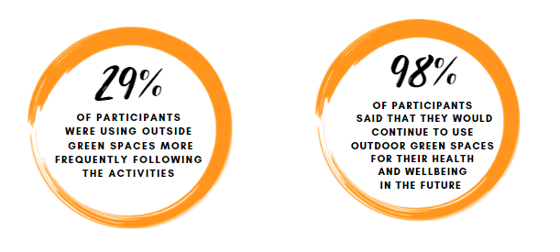

5-ways to Wellbeing Measures
The evaluation asks a series of rating-scale (1-5) to establish how far the activities are undertaken to align to the NHS’s 5-ways to wellbeing. The results are presented below.
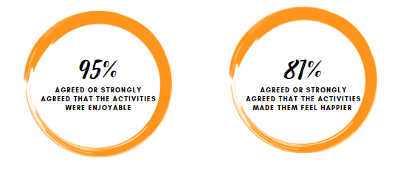
Mapping onto the 5-Ways to Wellbeing

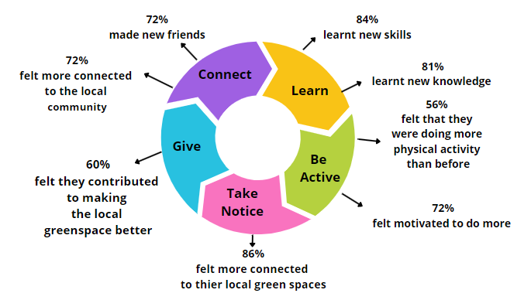

Inspiring changes in participants
The participants were asked an open-ended question about how the Trywydd Iach Activities may have inspired any changes in themselves (physical or mental wellbeing or environmental change) through the course of the programme. The responses were themed and coded into the following themes, mental wellbeing benefit, physical health benefit, social wellbeing benefit, learning new skills and knowledge, and being in nature benefits and environmental benefit (satisfaction/helping others). Some participants provided more than one response; in these instances, each response was coded individually. The chart below illustrates the impacts as stated by the participants.

The comments received reflect a fusion of impacts that often crossed over the themes. The key themes are illustrated in a selection from the comments received that are presented in the below table,

Improved mental wellbeing  “This has been completely transformational to my mental health and wellbeing. Being in a safe space with beautiful surroundings, supporting facilitators and like-minded people whilst learning new skills is more beneficial for any other counselling or treatment I have done (which is a lot!). A huge part of these groups is the sense of community they engender, and I cannot recreate that with independent woodland visits. I feel this group offers truly dramatic benefits for me”  (Participant, Ynys-Hir Woodland Activity Group & Animal Assisted Therapy)  “It has taught me how to relax and re-focus my thoughts away from the turmoil around me, in the news and on social media. It has renewed my ability to see the essential good in people and nature”  (Participant, Ynys-Hir Woodland Activity Group)  “It has helped me to be less anxious about going out and joining in with community activities”  (Participant, Animal Assisted Therapy)  “Being part of Actif Woods has been truly amazing! Although I still suffer from my mental health it has vastly improved. I feel like I want to connect with others again. It's a shame that its duration is so short. I really hope that funding gets increased as things like this actually change people's lives. I was blessed to be part of it and know that it helped everyone else in the group. I have also practised some of the skills that I have learnt in the course, which really helps to take my mind off things”  (Participant, Ynys-Hir Woodland Activity Group) | Social Wellbeing  “I think that the pandemic has resulted in myself and my partner becoming isolated due to being older and avoiding people in an effort not to catch Covid 19. Also, a recent house move meant we did not have the opportunity to meet people as easily. Trying new tasks and meeting like-minded people has been nourishing and life-affirming. I have enjoyed the sessions enormously and am going to miss going very much”  (Participant, Ynys-Hir Woodland Activity Group)  “It was great to have the opportunity to connect with other parents and do some crafts in a safe space for my daughter”  (Participant, Family Woodland Sessions)  “Meeting new people and I now love being in woodland areas”  (Participant, Woodland Activities Ynysmaengwyn)  Improved Physical Health  “Improved fitness. I always look forward to our group walk on Friday although I walk daily. It's great to have a chat with different people”  (Participant, Walking Group, Machynlleth).  “Being more active and making time for myself”  (Participant, Woodland Activity Group, Ynysmaengywn)  “Inspired me to get out and move more. Gave me the confidence to meet a group of strangers and interact”  (Participant, Ynys-Hir Woodland Activity Group)

Increased Confidence  “It's given me more confidence and meeting different people and being outside”  (Participant, Animal-Assisted Therapy)  “It has helped me to realise speaking up for myself is a good thing and knowing my own limits and boundaries”  (Participant, Woodland Activity Group, Ynys-hir)  “It has helped me to be less anxious about going out and joining in with community activities”  (Participant, Animal-Assisted Therapy)  “the walking group has helped me to get out of the house”  (Participant, Walking Group, Machynlleth)  Connection to nature  “It has inspired me to make sure I make time to re-set/be still in nature and how important and valuable outdoor health is to everyone. It was nice to meet people who value that”  (Participant, Animal-Assisted Therapy)  “It's changed the way I look and listen while outdoors. Just standing or sitting with your eyes closed and listen to your surroundings can bring calm to yourself”  (Participant, Woodland Activities Ynysmaengwyn)  “I think more than anything I was surprised at how it impacted on my mental wellbeing. I spend a lot of time in the outdoors, but on the course, I have learnt to connect and view it a different way which has made me feel calmer and refreshed”  (Participant, Animal-Assisted Therapy) | Provided Inspiration & Motivation  “It has made me do more outside. Even if it’s just a walk for 10 mins. These woodland groups have reminded me of being young and being outside. These groups help me because it's something to look forward to each week”  (Participant, Participant, Ynys-Hir Woodland Activity Group)  “It gives me the motivation to go out in the fresh air and meet with others”  (Participant, Walking Group Aberystwyth)  “I loved the chat and meal around the fire as well as the moment mindful listening practice. I have since enjoyed soup and mulled cider around my own campfire in my garden, with friends to celebrate the Winter solstice so it has inspired me to gather my friends’ round and use my own garden more. I’ve also been wild swimming in the sea with friends since and sat around a fire afterwards since so it's made me realise how much I enjoy this activity. It gives me a real boost and beats Winter blues”  (Participant, Family Woodland Sessions)  “It has taught me how to relax and re-focus my thoughts away from the turmoil around me, in the news and on social media. It has renewed my ability to see the essential good in people and nature”  (Participant, Woodland Activity Group, Ynys-hir)

Improvements
19 participants offered improvements that could be made to the activities. These are presented below for each type of session,
Type of session | Improvement suggested | Number of comments
Animal Assisted Therapy Session | More mindfulness activities  More variety in the mindfulness | 2
Woodland Sessions (adult) | More flexible on times to attend (weekends)  More locations that are easier to access (Tywyn/Aber)  Follow-on or continuation of sessions beyond 6 weeks  Resource sheets and more help for skills-based activities (i.e. woodworking) | 2  2  9  2
Woodland Session (Family) | Age-appropriate activities for babies-in-arms or target older children  Sessions are too long and not set up for babies-in-arms (especially during the winter) | 1  2
Walking Group | Vary the walking routes in Aberystwyth to maintain interest | 1

Overall Rating
Overall, the participants who completed their evaluation forms rated the Trywydd Iach activities 4.67 stars out of 5

Part 2 – Trywydd Iach: Healthy Travel

Active travel is a key priority in the Welsh Transport Strategy that dovetails with Wales’ Well-Being for Future Generations Act. Encouraging healthy travel (or Active Travel) is an essential government strategy that can benefit both human and environmental health. Central to this strategy is the need to encourage and support a shift towards emission-free walking and cycling as an alternative to car use. To achieve these goals a network of, “safe, direct, comfortable and attractive walking and cycling routes” are needed across Wales. Consultation undertaken during the 2019 pilot reinforced the need for safe walking and cycling routes within the Dyfi Valley that linked key villages and towns.
The Healthy Travel initiative was developed to actively encourage and support community members to contribute to the conversation about new routes and to support walking and cycling initiatives across the region.

Year One Outputs: Healthy Travel
Activity Undertaken | The target for year 1 | Achieved
Penparcau community consultation | 6 community consultations  (225 people consulted per year) | 6 community consultations  (321 people consulted)  (157 attended community consultation, 164 school pupils consulted )
Aberystwyth community consultations (x1)
Tre’r Ddôl community consultation
Machynlleth community consultations (x2)
Camaes community consultation
Secondary School Consultation
Healthy Travel Project Board Established | Establish Board | Project Board established
New routes proposed and mapped | 2 | On-going (for year 2)
Training provided | 10 sessions | Planned for year 2 delivery

Outcomes year one: Healthy Travel

7 Community consultation events took place between September and October 2021 to assess the needs regarding cycling and walking routes and potential barriers that might exist for cyclists and walkers. The events were arranged in Penparcau, Aberystwyth, Tre’r Ddôl, Machynlleth and Cemaes. A total of 157 attended the events. Comments from the community suggested that people valued face-to-face events.
People were encouraged to share their comments verbally or by written consultation. A total of 47 written consultations were received. The data collected in the consultations was shared with Powys, Gwynedd and Ceredigion Councils.
During the events, information was also shared about Powys and Ceredigion’s online Active Travel Mapping Consultation. Each Council must produce an Active Travel Network map which sets out its aspirations for new routes. 83 responded to the commonplace platform in Machynlleth and 89 in Aberystwyth. The total number of responses was much higher in these Towns than in the other Towns in Ceredigion and Powys as shown in the tables below.
Ceredigion
Aberystwyth | Lampeter | Cardigan
89 | 5 | 21
Powys
Town | Responses
Welshpool | 21
Llanidloes | 6
Machynlleth | 83
Knighton | 16
Ystradgynlais | 2
Brecon | 36
Builth Wells | 1
Llandrindod Wells | 5
Newtown | 6

The higher number of responses from these areas to the online consultation may have been a result of Trywydd Iach’s community engagements, as there was a higher response rate in both of the target areas. David Allday, Active travel Officer in Powys shared in a telephone conversation that the Council looks closely at towns with strong community involvement.

Recommendations from the Community Consultation events
There were several recommendations for route development received as part of the community consultation. These are presented below,
- Connect villages and towns along the A487 between Penparcau and Machynlleth with safe cycling and walking routes
- Footpath/ Cycle path between Dolfach –Llanbrynmair – Powys
- Extend cycle path between Penegoes and Glantwymyn.
- Need to improve walking routes from Llugwy along the Dyfi by Machynlleth and develop the former railway line into a multi-use path between Ffriddgate and Pantperthog -Gwynedd
- Improve routes between the town/ station/ school in Machynlleth
- Create a network of safe routes in Aberystwyth Town
A video was created by Trywydd Iach that illustrates the need for safer cycling and walking routes. This can be found here, https://vimeo.com/664469130/4301a1ce5b (this has been shared with Lee Waters, Deputy Climate Change Officer, Welsh Government)

Barriers
The community were also asked to highlight any barriers that they felt prevented them from using healthy transport more often. The key barriers were,
- Lack of connecting routes between villages and towns
- Cambers on cycle routes make it difficult for cyclists on tricycles
- Cycle paths should be maintained to the same standards as the roads. The hedges need to be trimmed and standing water and mud cleared from the surface
- Poor public transport
- Limited space for bikes on trains
- No provision for bikes on buses – a need for bicycle racks on buses
- There are a number of dangerous roads for cycling on – i.e. Derwen Las Village road dangerous bend, cycle path into Talybont ends up in a dangerous road before arriving into village.

Comments from Participants
Some of the comments from the consultation are presented below,
“Cycling puts my life at risk but it should be a pleasure and it is on certain routes. Cycling is the speed of life, for happy healthier lives”

“The route from Aberystwyth to Machynlleth is good where there are paths but they end up spitting you onto busy, dangerous sections!”

“I used to be able to cycle to Machynlleth from my home in Tre Ddôl. Now I’m slower I find it too scary on the uphill left bends, so now I am another car on the road making the situation worse for other cyclists”

“We need cycle provision on buses – rack on outside like in other countries and training for families”

“I live in Abercegir, east of Machynlleth. I would love to see a cycle path between Penegoes and Glantwymyn. This would enable me and my children to cycle to school and to the shops instead of driving every day.”

Secondary School Consultation
A sample of 164 pupils between 11 and 15 from a school in Machynlleth participated in the survey. The survey has identified that very few of the young people who were surveyed cycled to school. Increasing the number of pupils using Healthy Travel to get to school faces several structural and behavioural barriers. The main barriers are the distance some of the young people live from school making Healthy Travel more difficult. Moreover, free school buses provide a good alternative to many of the children who live in the rural villages. Most of the young people both live in Machynlleth and walk to school, but few showed an appetite for using active transport to get to school when asked. There was a small proportion of pupils interested in cycling to school, but distance and lack of cycle paths were cited as a reason for those young people not to attempt this.
However, the pupils expressed an interest in cycling and outdoor activities. The consultation identified that 25% of the young people would be interested in a bike club (see report – appendix A) The Project will explore the possibility of working closely with the school to encourage pupils to cycle to school

Healthy Travel Board
The Project successfully set up a Healthy Travel Board to guide and advise on engaging community involvement and developing new proposals for cycling and walking routes. A partnership between the three local authorities and Sustrans was successfully established.

Working in partnership
Working in partnership is seen as a key strength of developing the project and achieving its overall aims. The project has established important partnerships with the following,
Local Authorities | Officers from Gwynedd, Ceredigion and Powys County Councils
Charities | Sustrans
Town and Community councillors | Alun Williams – Aberystwyth Town Council  Ellen ap Gwyn -Councillor and Leader of Ceredigion County Council  Michael Williams, Machynlleth Town Councillor
Cycling groups | Wheel Together  Lorraine Langford -Breeze and Social Club  Ystwyth Cycling club
Community Organisations | Steffan Rees – Cered  Cletwr Community Hub – Tre’r Ddôl  Penparcau Community Hub  Tŷ Cemaes – Rural Hub  Beicio Dyfi
Local Businesses | Summit Cycles – Toby Brag
Local Primary schools | Plascrug and Talybont pupils created Active Travel Posters
The project will continue to nurture existing partnerships and establish new partnerships in year 2. Members from the Trunk Road agents are now also connected to the partnership.

New proposals for cycling and or walking routes
A strong theme emergent from the community events was the need for safe cycling and walking routes from Penparcau to Machynlleth. Following the advice from the Project Board, the project will therefore explore the possibility of acquiring funding to commission a feasibility study for the whole route in year 2 of the project.

Training sessions
The consultation allowed local voices and specific needs to be highlighted. Following the feedback received from the local people at the events, the project will develop the following training programmes during 2022.
- Improve women’s confidence to cycle safely on the roads
- Develop bike maintenance skills
- Provide cycling training for families
- Map reading skills
- Leadership skills
It is important to develop training programmes to meet and respond to the specific needs of the local communities to ensure maximum uptake and utility.

Areas of improvement
There were several areas of improvement and development highlighted by the project board at the end of year one of the project. These are as follows,
- Extend the members of the Project Board. A member from the Welsh Government Trunk Road Agent has been invited but hasn’t responded.
- Liaise with community and public travel agencies
- Deliver training programmes
- Explore funding opportunities to commission feasibility studies for walking and cycling routes

Conclusions – Year One Trywydd Iach Project

The Trywydd Iach – Outdoor Health: Social Prescribing project has provided a continuation of a joined-up system for referring participants to a range of multi-levelled outdoor activities. These activities have shown benefits to the physical health and the mental wellbeing of many participants. The project so far has illustrated how this method can engage with people with health conditions and match specific outdoor activities to people’s needs and abilities. The project is beginning to address some of the gaps identified in wider research around social prescribing, i.e. strengthing and streamlining the connection between the health sector and outdoor providers; having a single point of entry for multiple activities; taking pressure off the health sector to match participants with activities and; providing evidence of the effectiveness of these types of interventions.
The points of note for this evaluation are as follows, although 50% of participants had come through referrals and 50% self-referred (although many had health issues) only 12 came from the GP surgeries/NHS referral. Analysis shows that some surgeries were more proactive than others in referring participants. The lack of numbers directly from GP surgeries was connected to the Covid-19 pandemic that has increased GP workloads and prioritised vaccinations and boosters giving GPs and Practice managers less time to engage with the project. Referrals were more forthcoming from other health and support organisations.
Analysis of the demographics of the participants showed that 78% of the participants were female (the walking groups attracted almost exclusively female participants) and only 22% were from areas 1-5 WIMD (most deprived areas). The project will try to address this in year two.
It was noted that some participants felt that the 6-week sessions although successful, were not long enough to create a continued method to support people with long-term health needs, both mental, social and physical. As a response to this, the project set up monthly sessions for the woodland and animal-assisted therapy sessions as well as supported a participant to establish peer-support sessions. The model of a 6-week programme, followed by a monthly open-access drop-in session is potentially a working model that will both kick-start someone's engagement and offer continued support longer-term – however the model of supporting participants to set up their groups is also worth investigating as a more sustainable longer-term option. The feasibility of the existing model and cost-effectiveness of a new model will likely be a focus for year two (focusing on how to support the maximum number of people most effectively within the confines of time and funding available)
The Trywydd Iach – Outdoor Health: Healthy Travel project has been successful in engaging the community and collating views about healthy and low carbon travel options. Their views have been shared with the Local Authorities and will hopefully lead to improved outcomes for the communities. Trywydd Iach will hopefully secure funding for commissioning a feasibility study for new walking and cycling routes. The face to face consultations was valued by the local community and the online consultation set up by the Local Authority has enabled an easier way for some people to consult on Active Travel Mapping. The consultations highlighted the need that people living in rural areas to have safe short walk and cycle routes that connect them to key towns or villages that are, at present, lacking connecting pavements or cycle routes that make them safe to do so. The consultation established several key areas where this may be a priority (i.e connectivity even within Machynllth – between the station the town, Derwen Las Village road dangerous bend, cycle path into Talybont ends up in a dangerous road before arriving into the village). Year two will focus on developing more connections with the community and with key organisations that can help make the change.

Recommendations
Trywydd Iach: Social prescribing
- Connect with GP surgeries to establish any barriers/blocks to referrals
- Ensure activities provided can attract men and women
- Consider how to attract more people to the surgery walks
- Consider the timings of the sessions to be able to attract a wider range of people (at present all are within working hours Mon-Fri)
- Review the model of delivery so it works best for participants longer-term within the confines of the funding
- Consider reviewing the model of the cluster where the project officer is managing the cluster and also delivering sessions.
Trywydd Iach: Healthy Transport
- Seek views from a wide range of individuals and groups. People who are not supporters of cycling and walking will also offer useful insights.
- Ensure that there is fair geographical representation in our future events. Ensure that we engage all the communities in the Biosphere e.g. Tywyn.
- Liaise with National/ Local transport services to develop provision for bikes on buses
- Work with partners to develop a range of targeted training programmes

The surgeries that were involved in the project are Dyfi Valley Medical Prcacice, Machynlleth, Church surgery, Aberystwyth, Borth Surgery and Tywyn Health Centre.
This gives a sample size (95% confidence level, 7% margin of error). Further evaluation forms are expected in the coming months from walking groups that should result in a 5% margin of error.
The 14 WEMWBS indicators are: I have been feeling optimistic about the future, I’ve been feeling useful, I’ve been feeling relaxed, I’ve been interested in other people, I’ve had energy to spare, I’ve been dealing with problems well, I’ve been thinking clearly, I’ve been feeling good about myself, I’ve been feeling close to other people, I’ve been feeling confident, I’ve been able to make up my own mind about things, I’ve been feeling loved, I’ve been interested in new things and I’ve been feeling cheerful.
Brag, Wood & Barton, 2013 Health and the natural environment: A review of evidence, policy, practice and opportunities for the future, Exeter University, 2018 and Cervinka, Renate, Holtge et al, 2014. Green public Health – Benefits of Woodlands on Human Health and Well-being. Austrian Research Centre for Forests, Pretty J, Peacock J, Sellens, M and Griffin, M. 2005. The Mental and Physical Health Outcomes of Green Exercise’ International Journal of Environmental Health , 2005 15 (5) 319-337. Park, B et al. 2010. The Physiological effects of Shinrin-yoku: evidence from field experiments in 24 forests across Japan. In Environmental Health Prev Med 2010 15 (1) 18-26) to name a few
Natural Resources Wales survey 2014, 2018.
Health in Wales, NHS. http://www.wales.nhs.uk/healthtopics/conditions/mentalhealth
Torjesen, I (2016) Social prescribing could help alleviate pressure on GP’s, BMJ 352; 143
The Warwick-Edinburgh Mental Wellbeing Scale (WEMWBS)
Validity of the international physical activity questionnaire short form (IPAQ-SF): A systematic review (nih.gov)
EQ-5D (euroqol.org)
https://gov.wales/sites/default/files/publications/2022-01/active-travel-act-guidance.pdf
Evidence gathered in the form of, Details of participants – NAS 11. Monitoring, Evaluation …. Monitoring of Healthy Travel NAS Photos of events NAS 10. Photos 19Sep21events Video of events
Evidence can be accessed through, Details of written consultations NAS 11. Monitoring, Evaluation …. Monitoring of Healthy Travel, Powys residents, Ceredigion residents, Gwynedd residents.
Evidence for this: NAS 6 Project Board Documents Trywydd Iach –Healthy Travel Board Meeting minutes NAS 14 Active. Healthy Travel - Healthy Travel Project Board Presentation 2021NOV05

