Plas Hall Community Centre Machynlleth. June 2022.
Consultations on the development of the entrance to Y Plas Hall as an outdoor shared community space.

The current and only entrance is used for events for dancing, yoga, classes, meetings, craft stalls , shows, festivals etc. it is unsigned ,awkwardly ramped, grubby, muddy unsuitable for a grade 2 listed building, shown below.

Machfringe propose a new entrance which includes a performance area.

Machfringe has begun consultations in Machynlleth to ascertain the need, possible uses and desires of those using the community centre as to its design and future.

Machfringe has negotiated with Freedom Leisure who have a lease on the car park adjacent to the entrance. Freedom Leisure have agreed in principle to relinquishing four adjacent parking spaces to allow audience seating, a wider approach and area for performance. All subject to PPC approval and redesign.

20 June 2022, the architects George and Tomos are working on further design modifications.
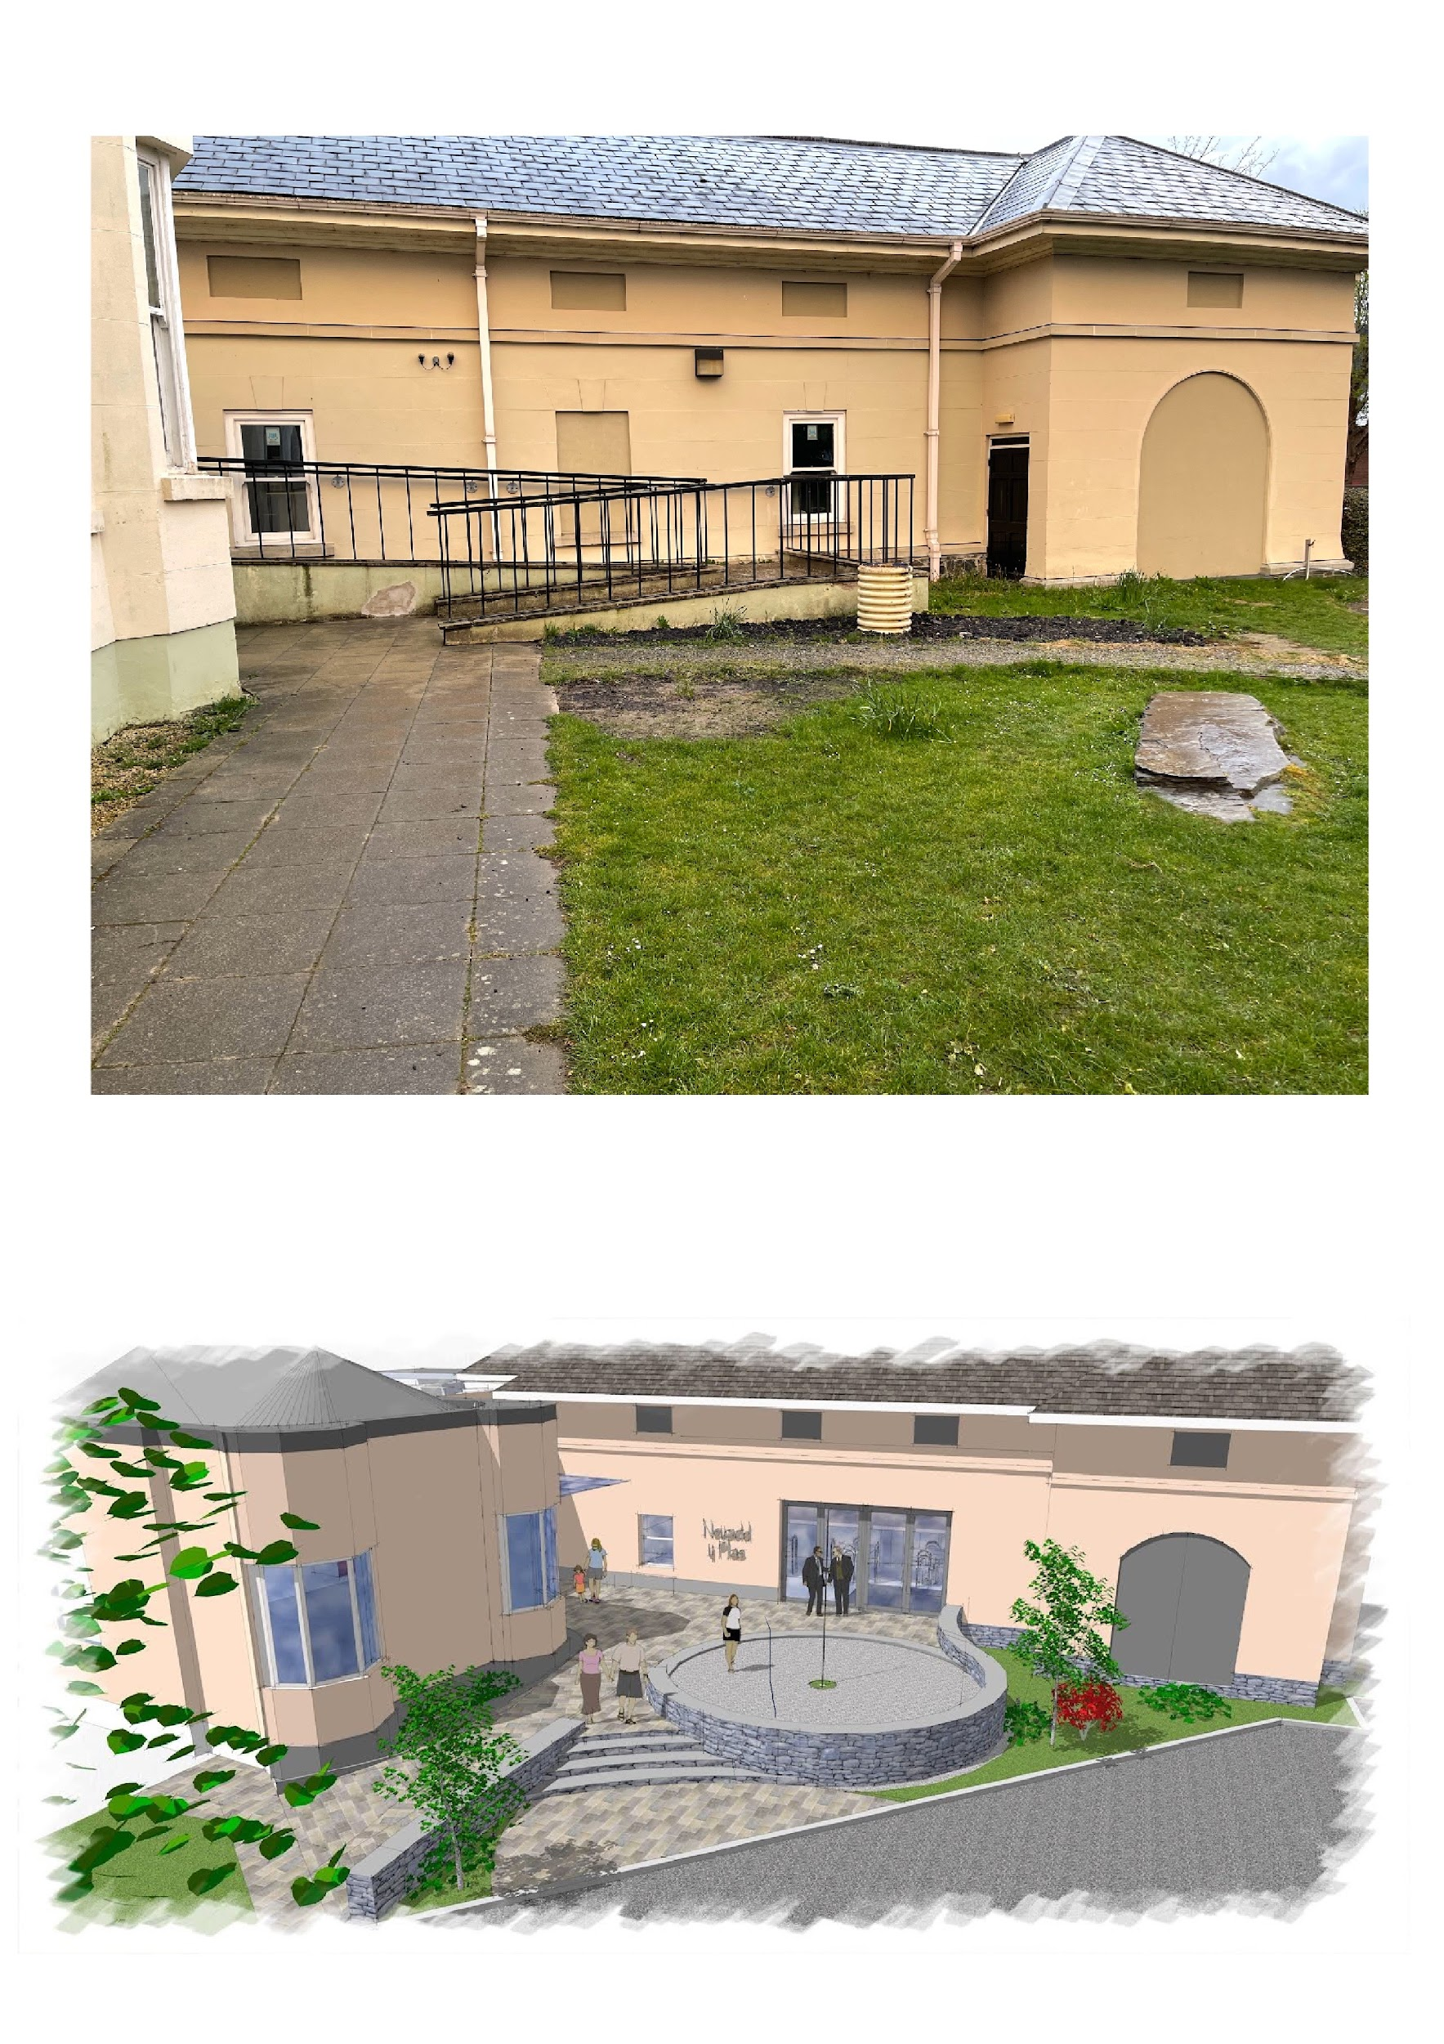

Consultation 1
This was carried out on face book and informally questioned the public. We showed people a sketch of a possible new entrance and asked people what they would like to see included in the design.

Results.
Consultation 1
100% approval and desire for improvement.
A desire for cover (removable?)
Safe surfaces and accessibility.
A performance area.
An improved appearance and use-ability
Removal of car parking close to the area.
Facility for bikes/ locking etc.
A gathering area with seating
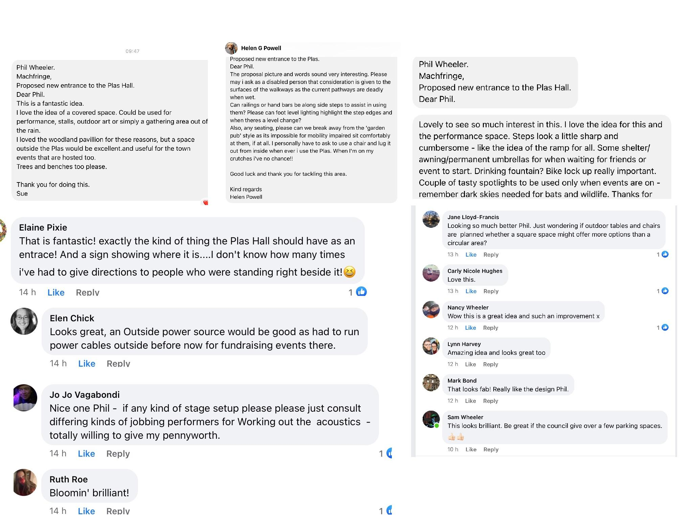
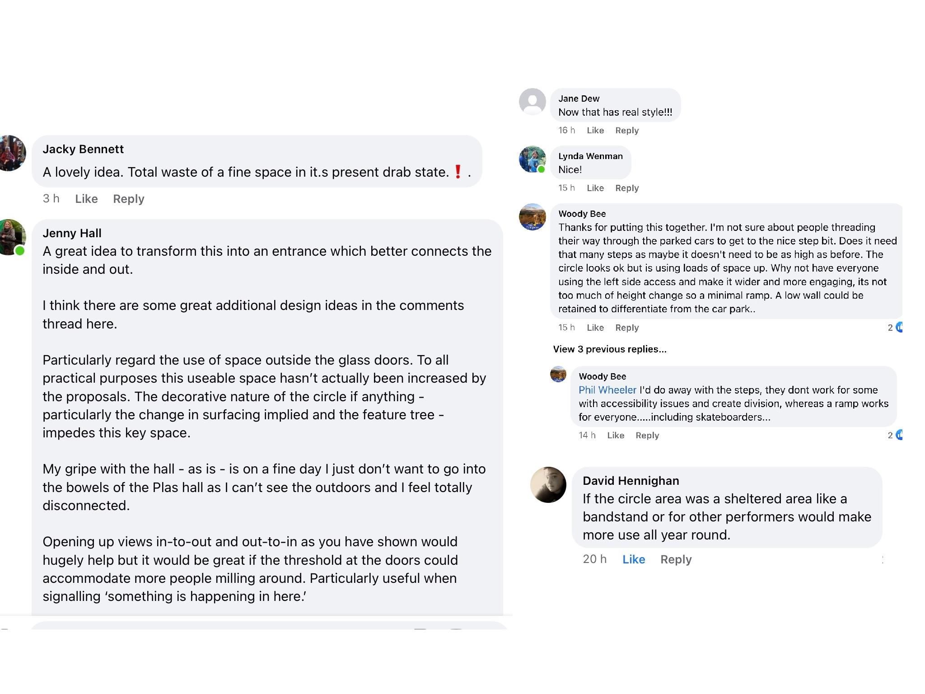

Consultation 2
This was at an event in the Plas hall. We used some of the suggestions offered by the public to give a tic box choice. We asked people to choose what they would like and add further suggestions by writing on cards and plans.
This took place as part of an event at the community centre.(Plas hall)
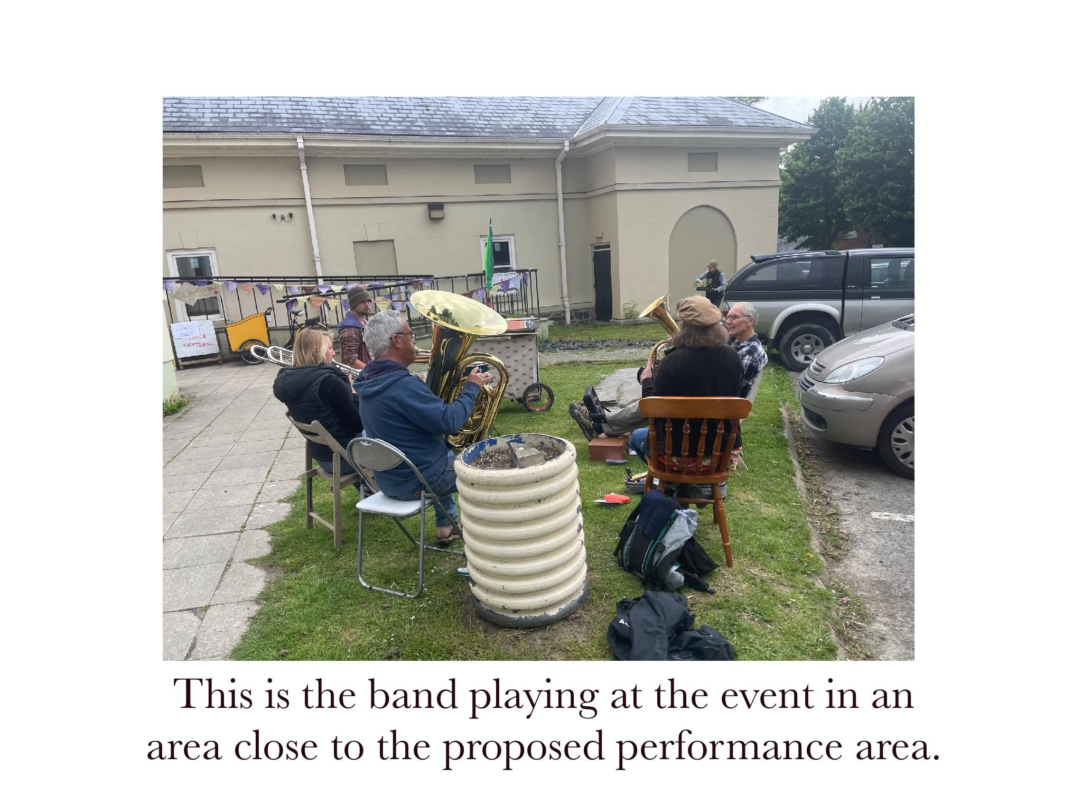
When the car park is reclaimed from PCC the cars shown would be elsewhere and the parking area would become part of the performance/seating area.

The event.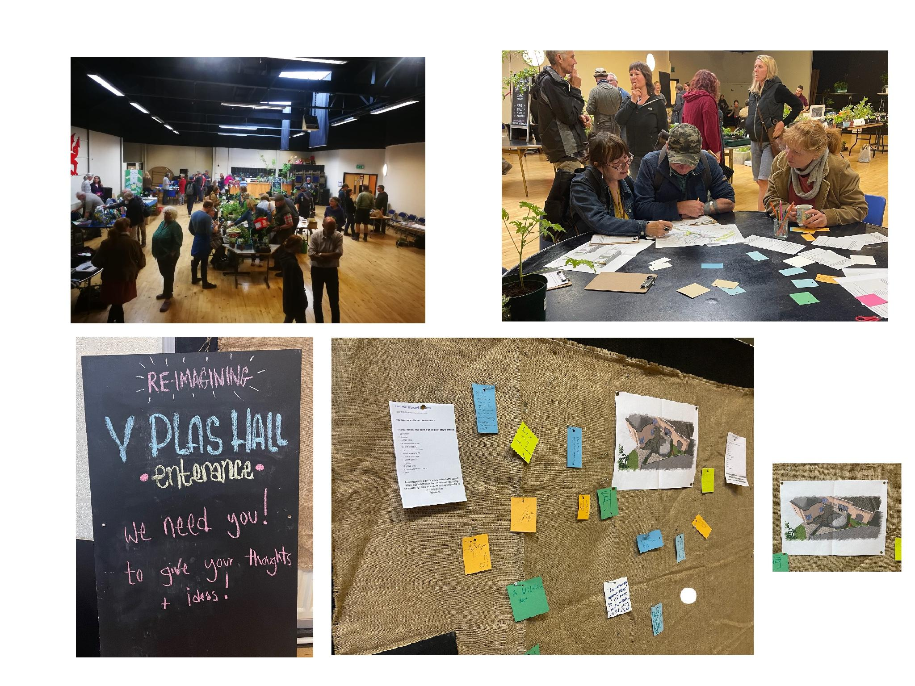
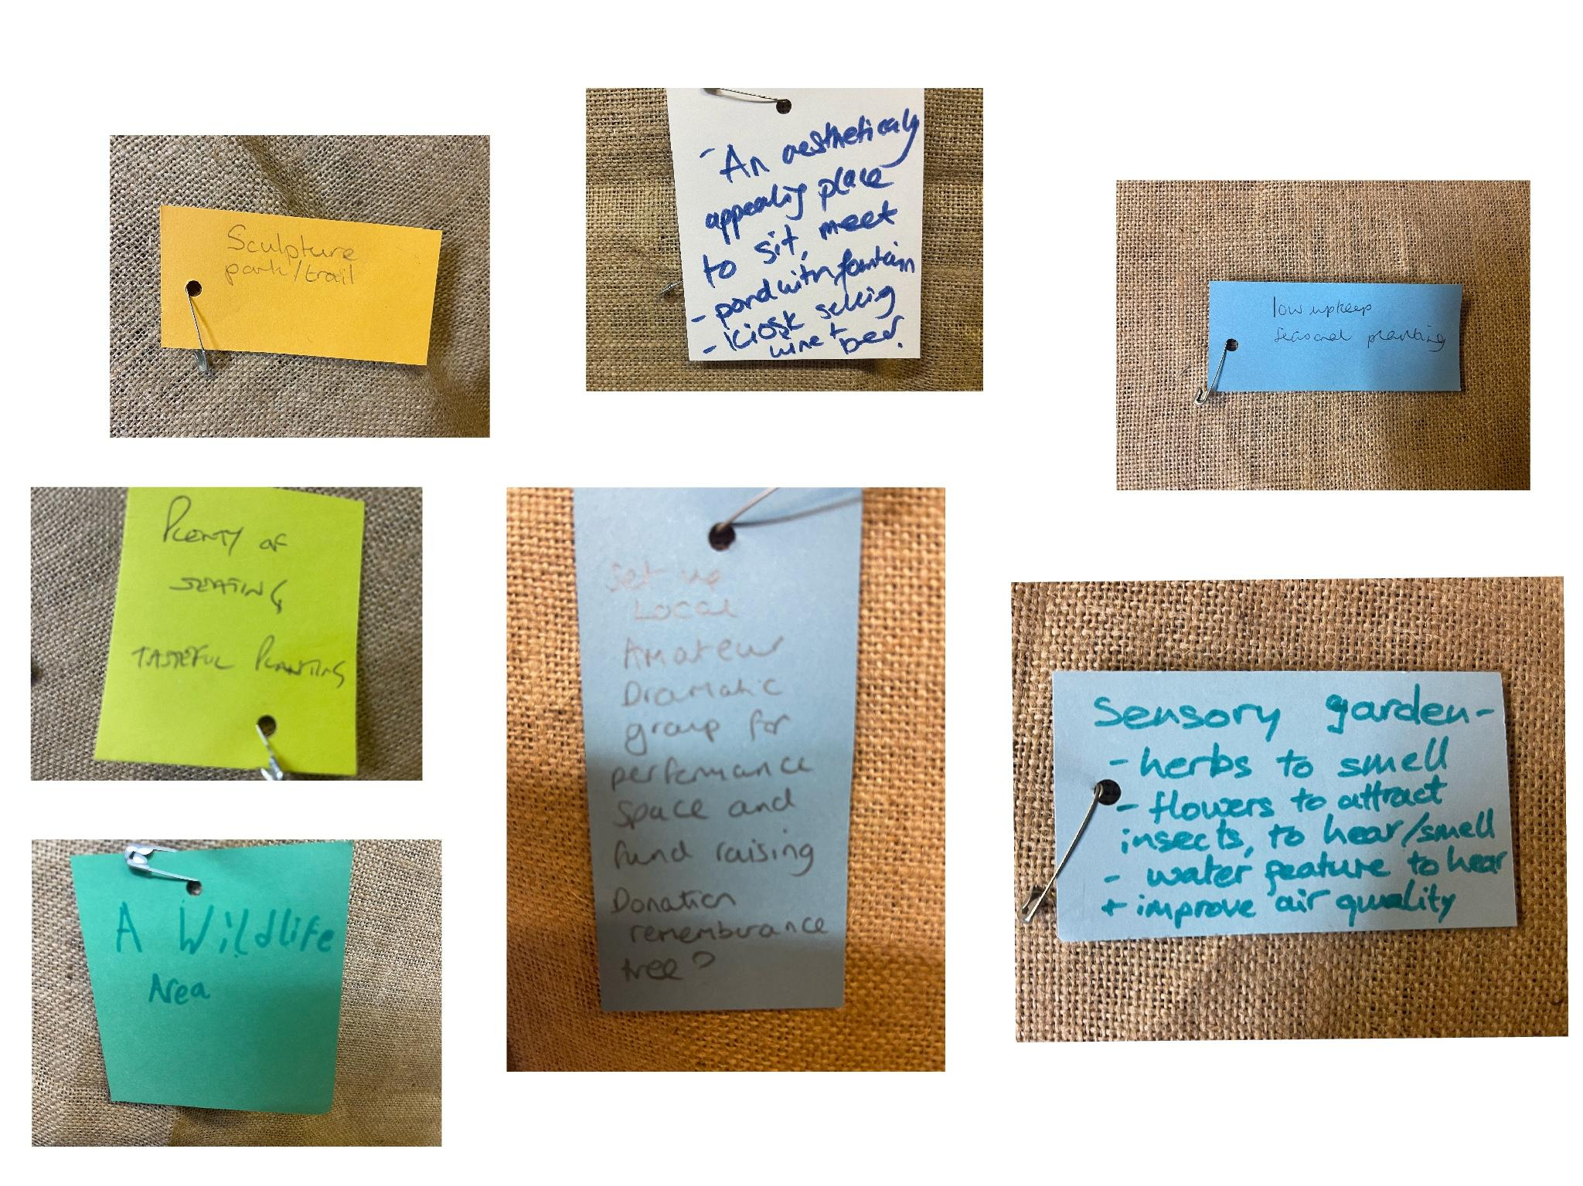

Results consultation 2.
100%approval
A desire for more separation of the area from car parking.
The inclusion of green area
Seating
Performance area.
Arts area

Consultation 3

This was carried out on market day in Machynlleth over a two hour period and used the same method as consultation 2.
We gave out tic box forms and asked local people for suggestions and to tick the items that they would like included.

Results consultation 3.
Items like ‘fountain’ or ‘sound system’ had been suggested and were included but were generally not favoured.
Items like ‘ seating’ ‘ performance space’ ‘games area’ were favoured.

Consultation responses below.
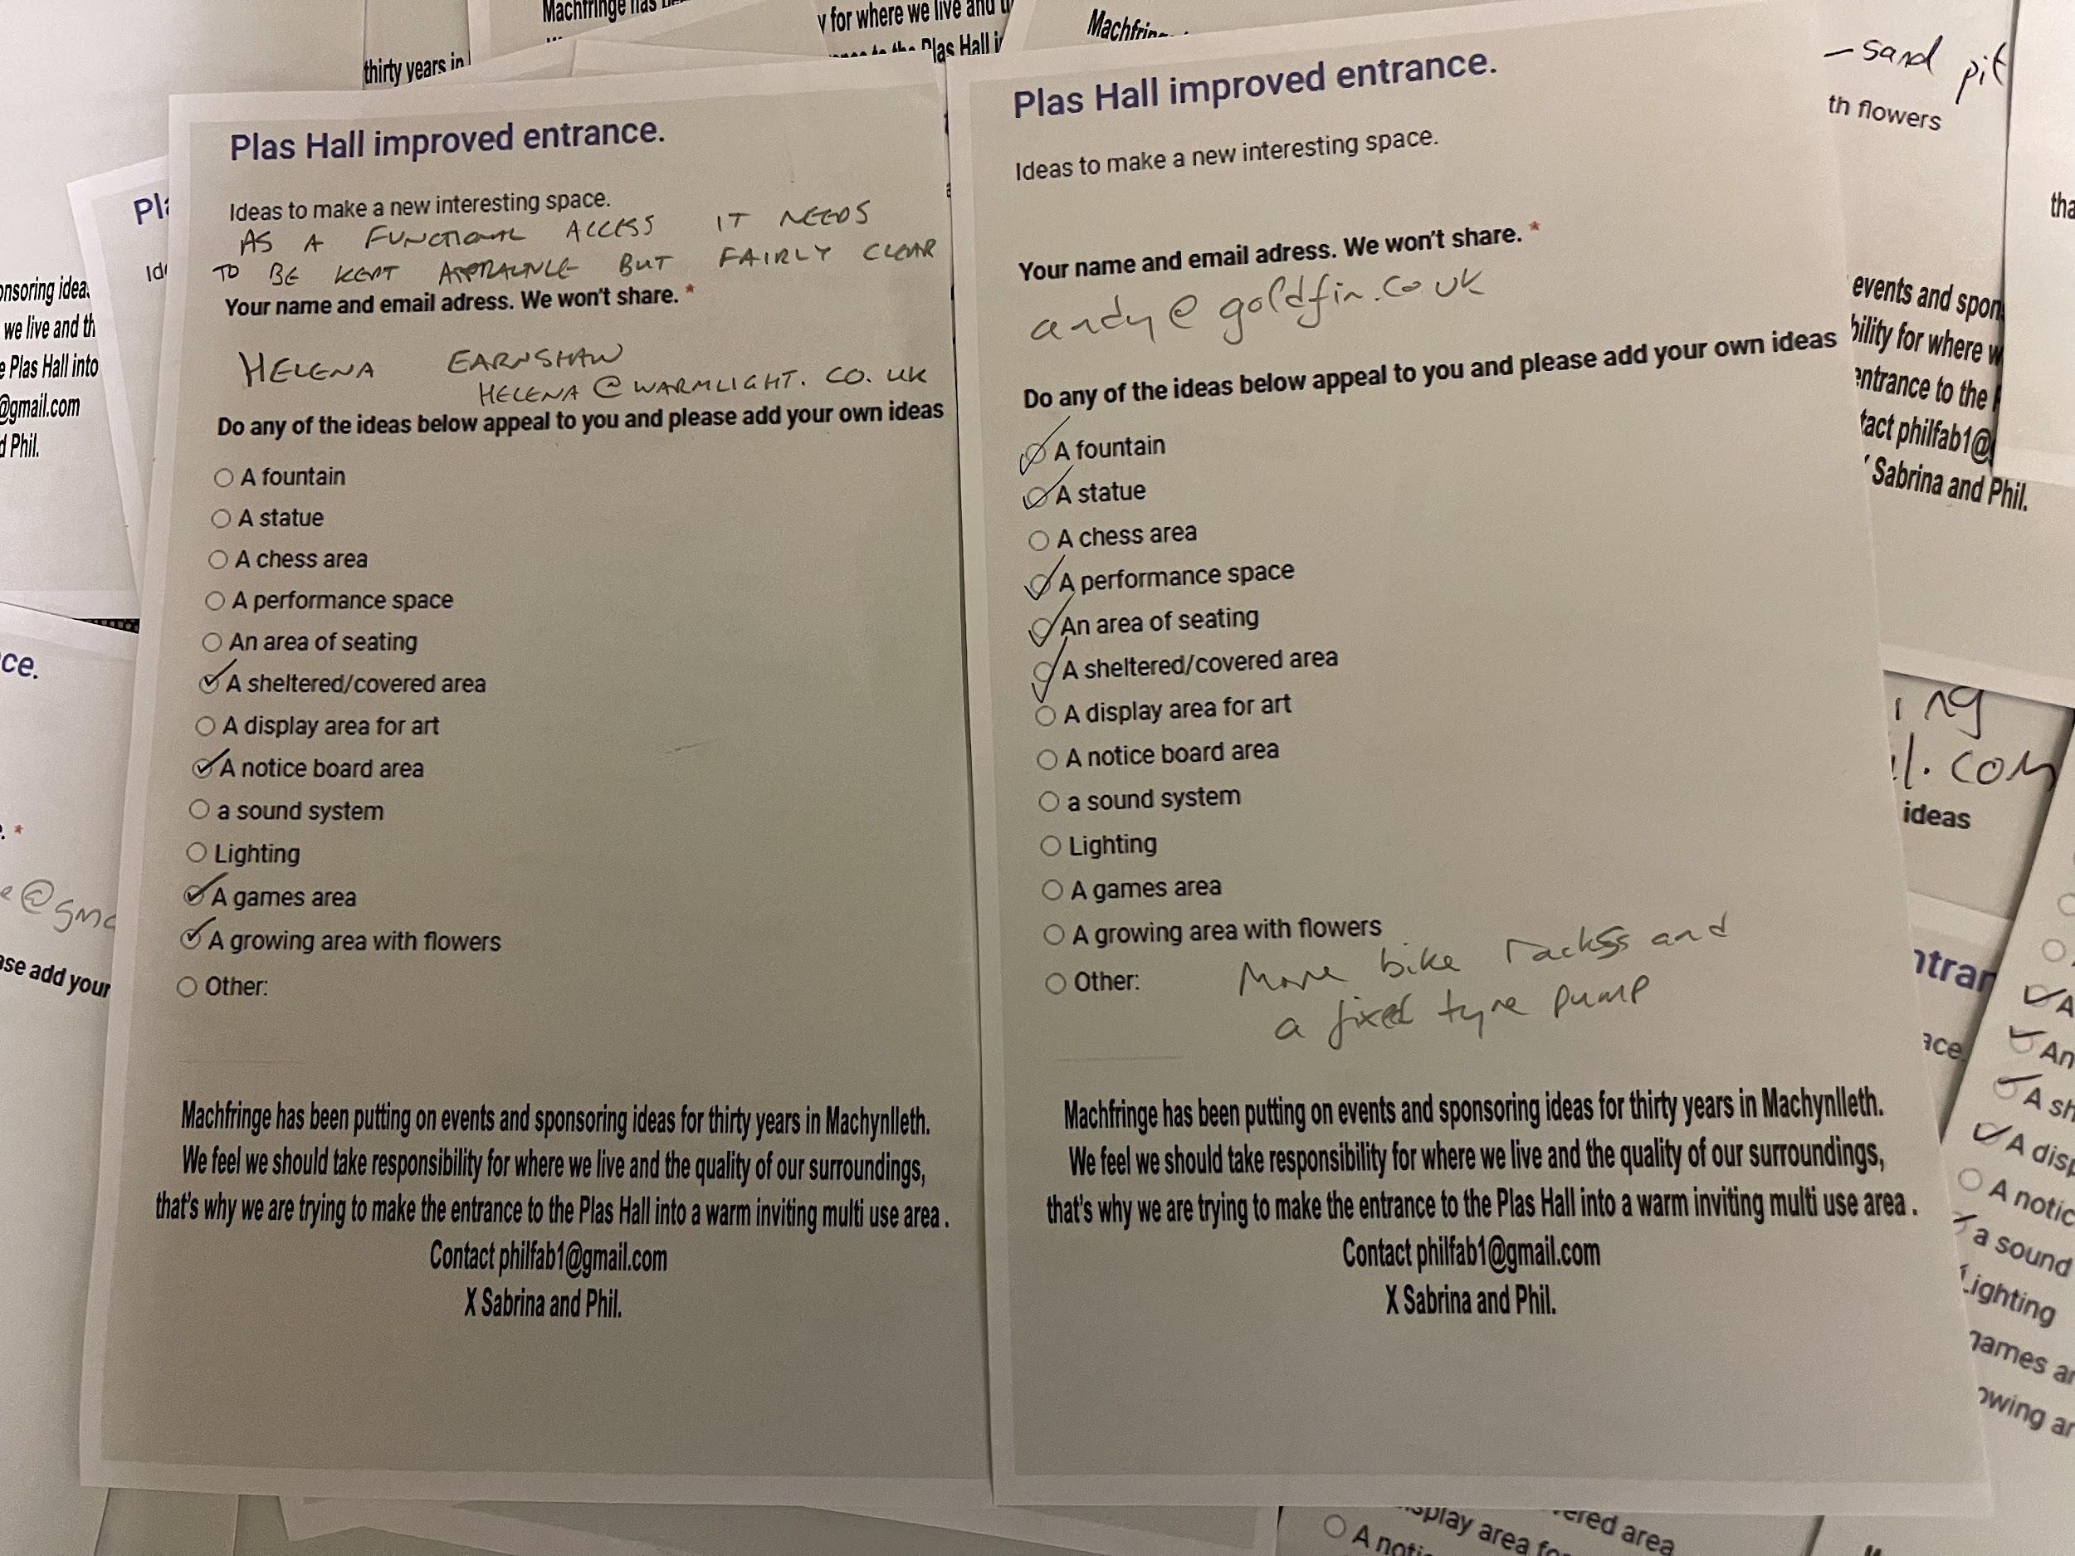
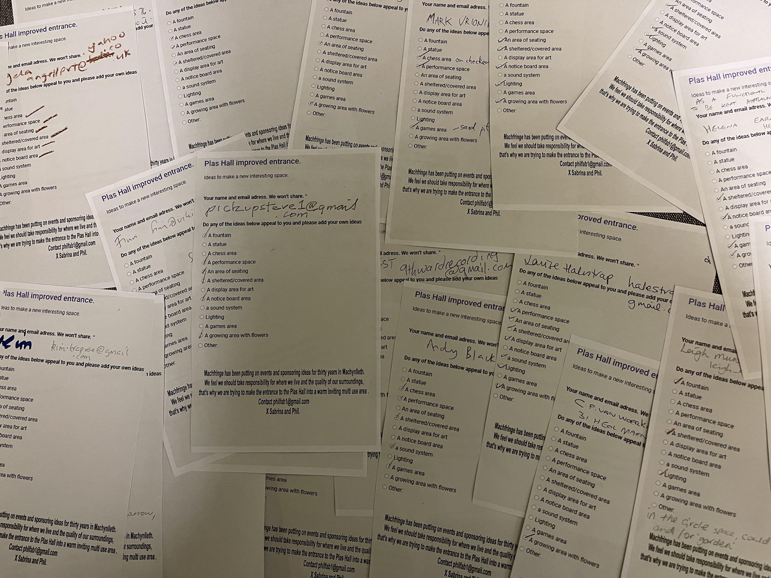

Consultation 4
Ongoing consultation asking users of the hall for their views.
Eg from a hall user

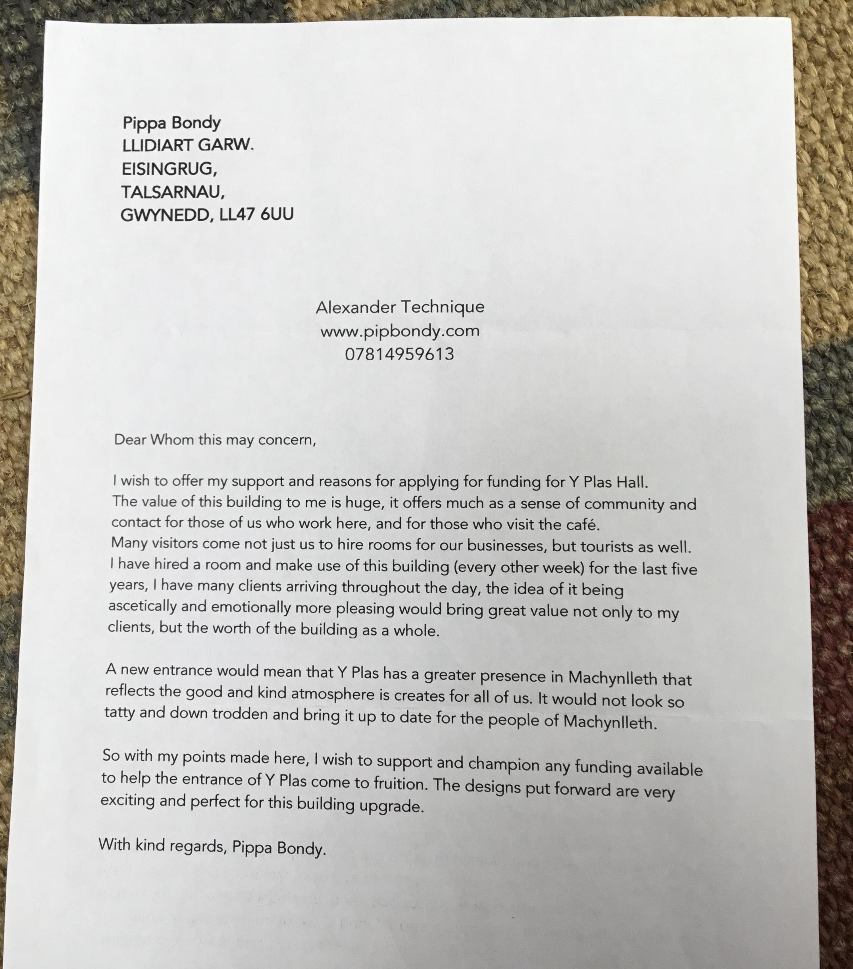

Eg from a potential performance space user.

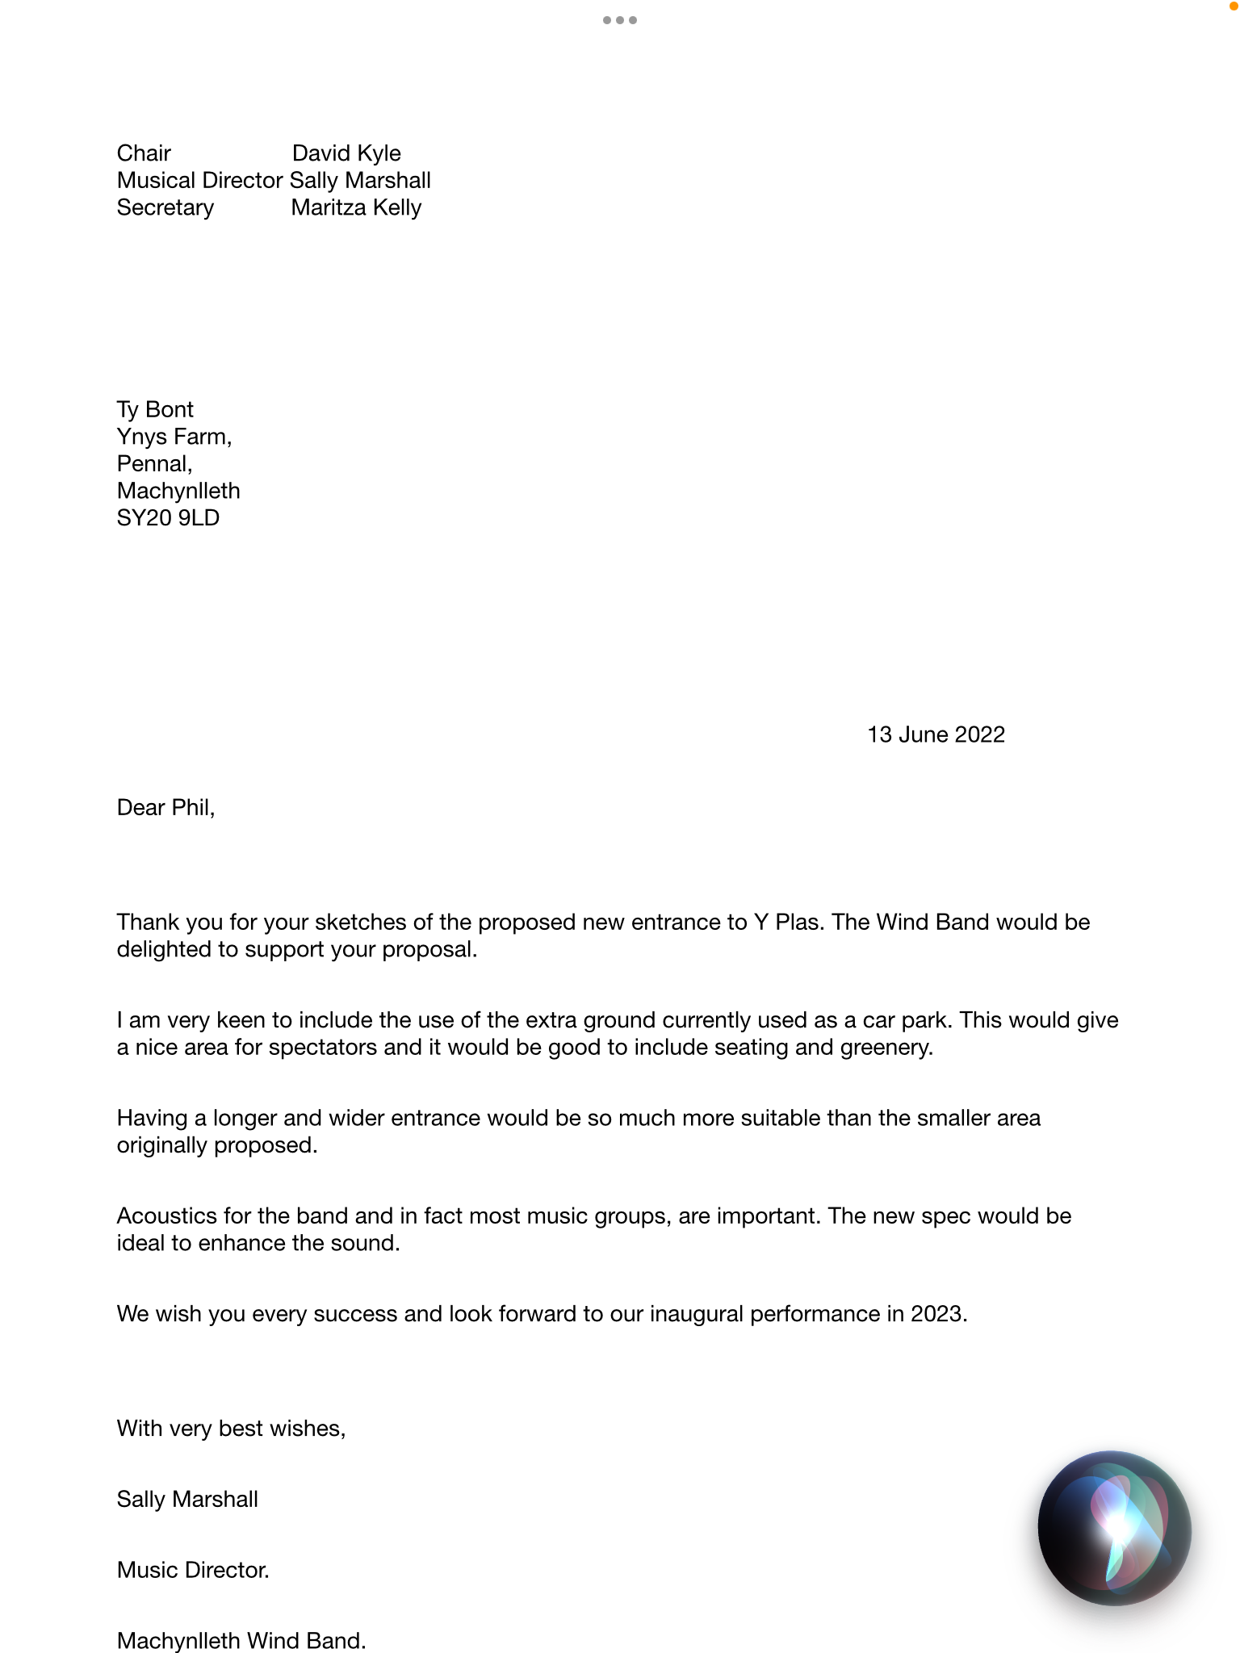

Eg from MOMA a potential user of the space.

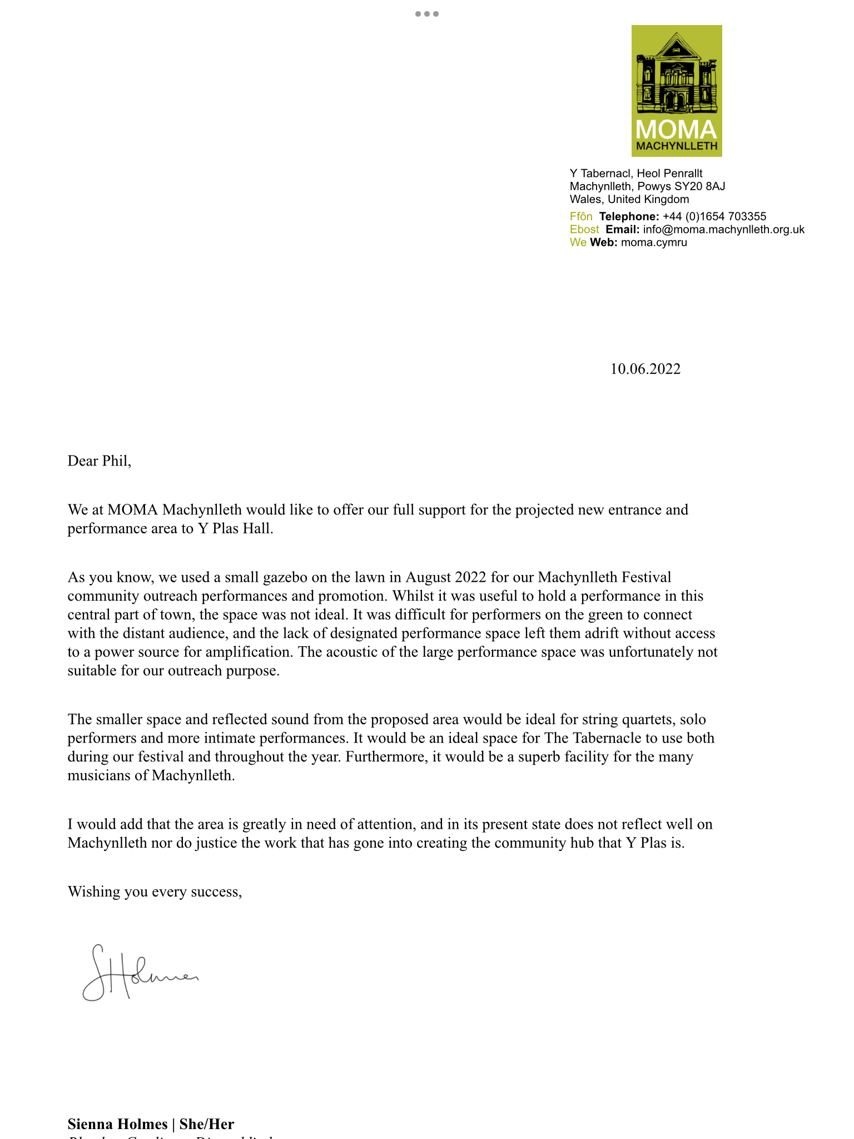

Overall Conclusions

We had one respondent who said’ just give it a lick of paint’
All other respondents have been in enthused and in favour and have suggested the following.

The project needs to have a performance area.
Improved accessibility.
A covered area.
Seating
A green area.
Signage.
Enhanced visitor flow.
Welcoming aesthetics
An area that would encourage and be suitable for young people,
This might be seating or games area eg fixed table tennis.

Finally, one correspondent who contacted us pointed out the need for a gathering space. She was often waiting in her car along with others who had children or partners , they would sometimes crouch between cars to talk with each other. She believed that a gathering space was really socially important.
She also emailed
fromJulia Stevens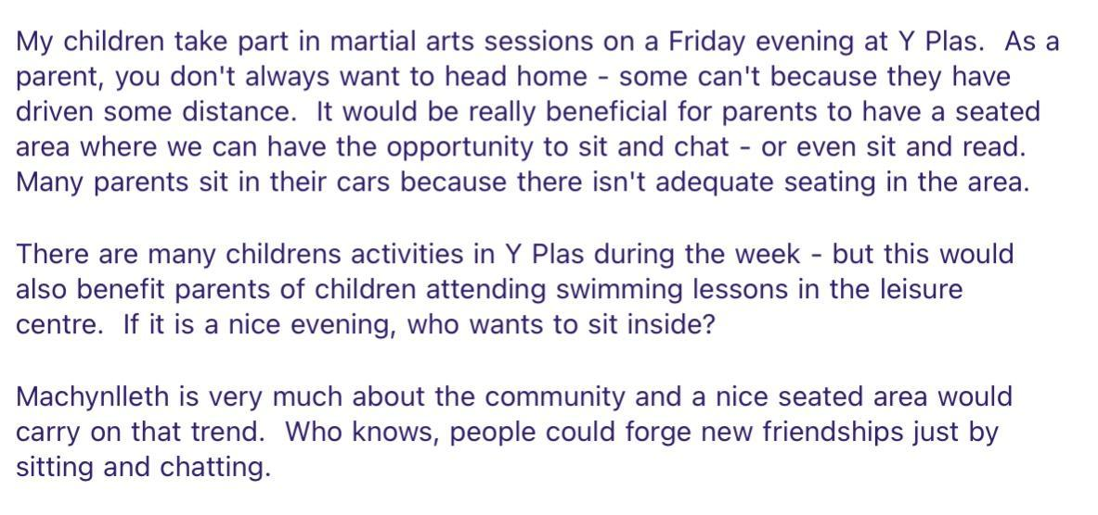
Funding

The funding we are seeking is for development of the project.
The overall value of the project is not known as it is still in development
Inflation also makes it hard to define.
The overall value will be in excess of £100,000 see estimate below.
We are seeking 10% of this from PAVO which will cover some architects fees, artists fees, tendering costs and planning.
Any balance of development will be funded through Machfringe by myself and my wife Ann.

Architects estimate. These costs will increase. The amount we are asking for is shown in green at the bottom- architects fees and planning costs.

