Ecodyfi Job Description & Person Specification

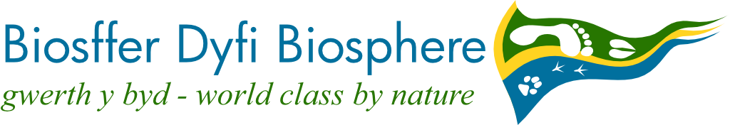
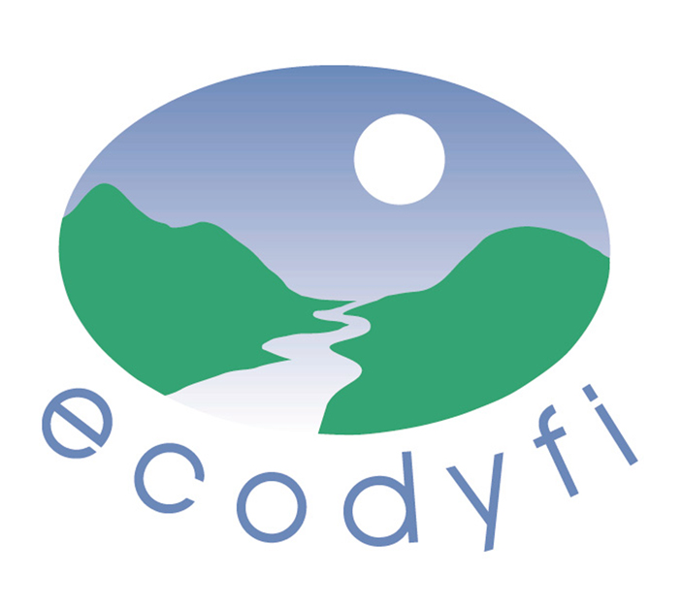

Job title: Ecodyfi and Dyfi Biosphere Coordinator

Job purpose:
The job is divided roughly 50% for Biosphere coordination and 50% for managing ecodyfi, including development and fundraising for both. The overall purpose is to lead the development, organisation, resources and capacity of ecodyfi, so that (in partnership with others) it can plan to deliver real economic, environmental and social benefits to the community of the Dyfi Valley and Dyfi Biosphere area.

Main tasks

Ecodyfi management and development
- Develop new projects and funding, including the development of earned income, that are consistent with the aims of ecodyfi.
- Supervise existing projects and report to the ecodyfi Board and Management Committee on progress, funding and outcomes.
- Prepare a forward plan for ecodyfi together with Board members, staff and other stakeholders and for final approval by the Board, to achieve sustainable funding for the organisation and its projects.
- Ensure ecodyfi maintains excellent links with appropriate partners and stakeholders, both locally and more widely.

Dyfi Biosphere coordination
- Facilitate partnership working through providing Secretariat services to the Dyfi Biosphere, including helping to review the governance and administrative arrangements.
- Develop engagement of all kinds of stakeholder, as resources permit, including joint working with other area-based partnerships.
- Help the Partnership secure resources to ensure increased resilience and impact.

Joint tasks
- Communicate with the ecodyfi Board and Dyfi Biosphere partners so as to keep members sufficiently informed.
- Help to raise the local profile of ecodyfi and the Biosphere.

Contract:
Permanent, subject to funding, with a review effective after 12 months.

Responsible to:
Chair or other designated Director on the ecodyfi Board; the Board as a whole; and to the Dyfi Biosphere Partnership for Biosphere activities.

Line managing:
Other paid staff, contractors and volunteers, unless their job description or contract states otherwise. During 2024 this is anticipated to include:
- Ecodyfi’s Financial Administrator (0.8 fte);
- ‘Tyfu Dyfi’ (Growing the Local Food Economy) staff –
- Project Manager (0.4);
- 5 other part-time Tyfu Dyfi staff, who also report to the Project Manager.

Collaboration:
Close collaboration is required with key partners, not only project delivery partners such as Criw Compostio and Coed Lleol but with strategic stakeholders in the public, community and private sectors.

Salary scale:
In the range £33-37K depending on skills and experience.

Hours of work:
Ecodyfi is a flexible employer. Within a flexitime arrangement, the average hours worked per week is 37.

Holidays:
There are 22 days of annual leave, plus the 8 bank holidays, plus 1 discretionary day, making a total of 31 days.

PERSON SPECIFICATION

Essential experience, knowledge, skills | Desirable
Experience of developing and managing projects, and of securing resources for their delivery | Experience of managing a small business or third sector organisation
Experience of grant management and reporting | Experience of monitoring and evaluation
Experience of leading a team and supporting committees | Experience of partnership working or collaborations
Experience of managing paid and/or unpaid staff | Experience of organising, promoting and/or encouraging participation in community action
Knowledge of sustainable community development | Experience or knowledge of nature-based responses to the climate and nature emergency that deliver multiple benefits, such as sustainable energy, agroecology, or social prescribing.
Excellent interpersonal and communication skills | Good knowledge of the local community
Comfortable in both Welsh and English | Current driving licence
Comfortable with numbers
Comfortable with using ICT
Ability to work independently with minimal supervision; self-starting and proactive

Why work for ecodyfi?
- Established reputation for knowledge and practice of sustainable development;
- Many local partners with relevant experience;
- Chance to join national and international UNESCO Biosphere programme;
- Supportive management committee;
- Training and professional development supported;
- Track record of attracting committed and capable co-workers.

