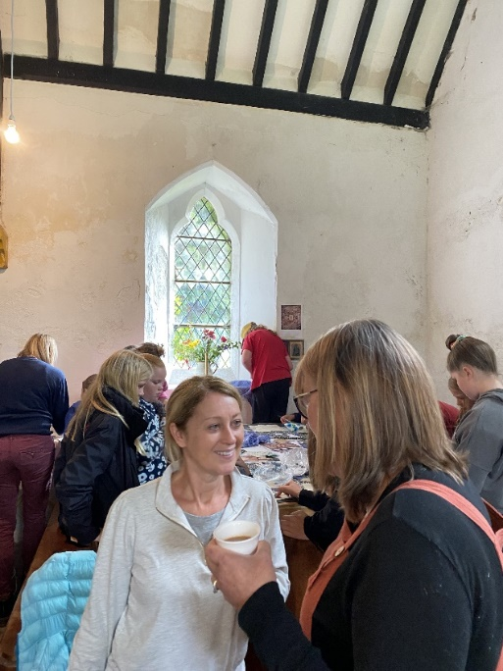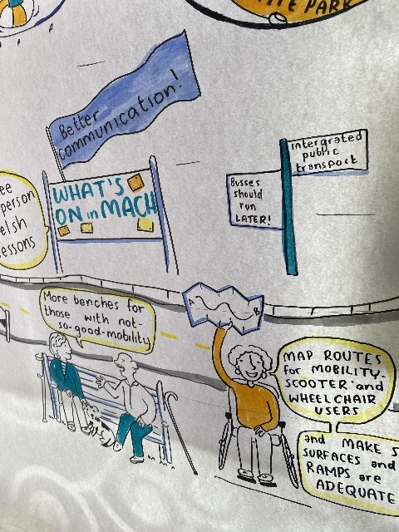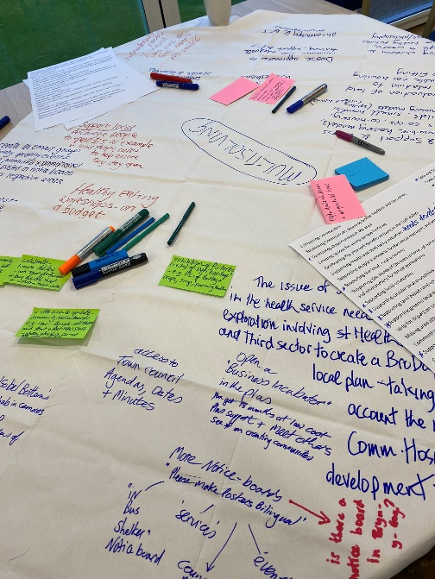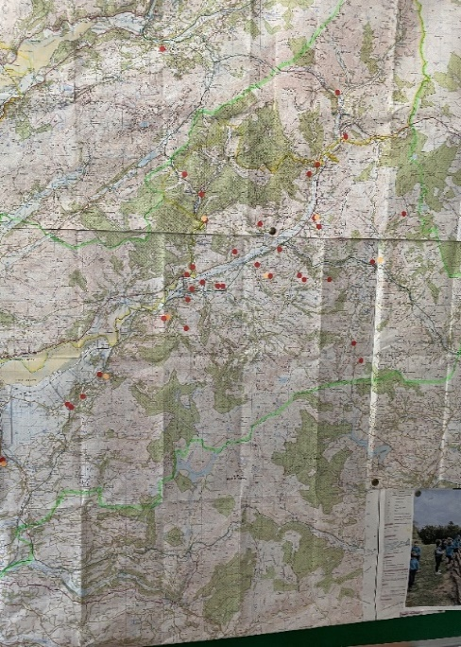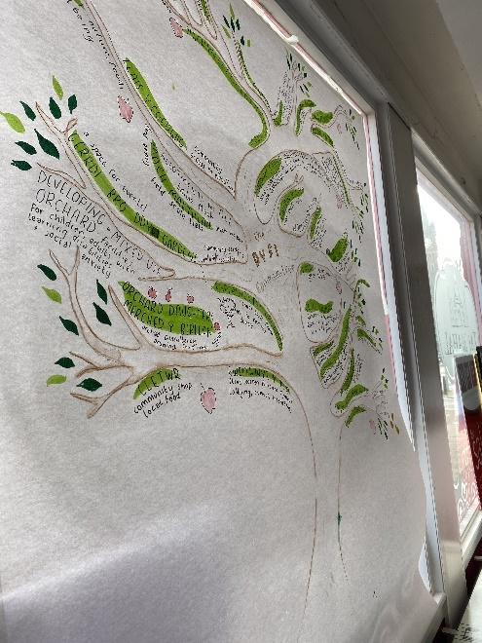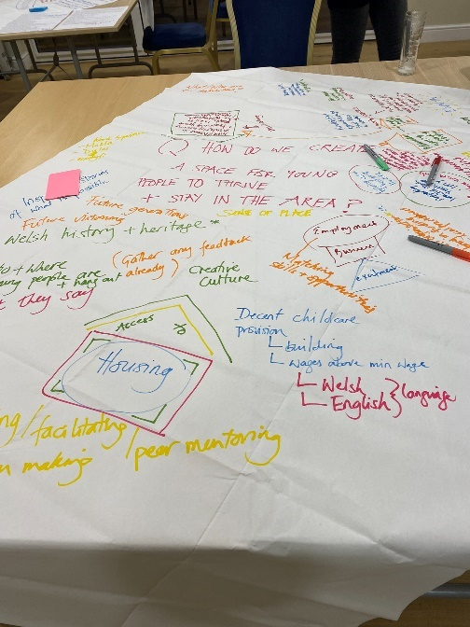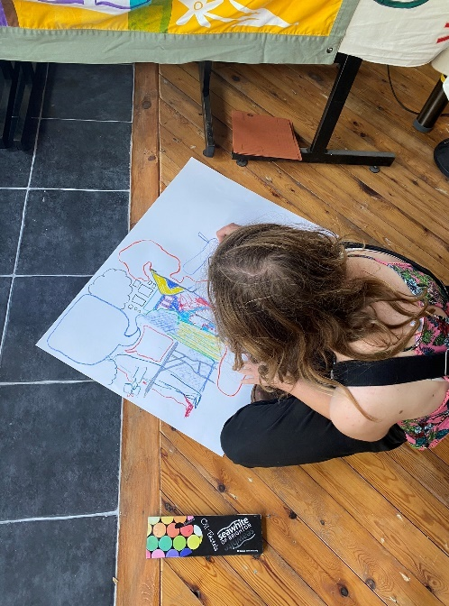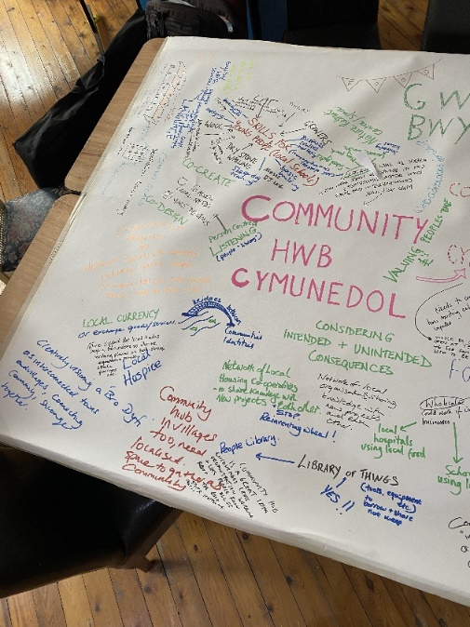
Dyfodol Dyfi - Planning a Brighter Future
1. Summary
The Dyfodol Dyfi project is a project working to bring communities together along the Dyfi; to gather needs, share information, develop ideas; to build a brighter future.
The project’s initial focus was to support the community to prepare for UK Shared Prosperity Fund however it was also recognised the project could widen its scope to support communities for any future funding applications.
It aimed to create a Community Plan which could offer an ‘evidence of needs’ bank to be accessed and used by everyone alongside a document which could be of current and future use for any organisation seeking funding for a project in the area.
The project mapped the many surveys, feasibility studies and proposals from recent years to create a foundation on which to build a series of engagement activities which then offered fresh evidence from the summer’s conversations as part of Dyfodol Dyfi.
It chose to be creative in its engagement focusing on conversation, listening and a process of creative visioning with the community alongside more traditional online and paper surveys.
It included conversations with over 600 people including individuals, small businesses and sole traders, voluntary organisations, community councils, town council.
It’s most successful engagement activity was the opening of a pop up shop in the centre of town for 8 days inviting the community to share, respond and have conversations with facilitators working to creatively vision the future of the area. Alongside this was an ongoing process of one-to-one meetings, attendance at local events, social media posting working through and across multiple platforms and networks.
Though operating within a short time frame it achieved significant engagement across a diverse demographic and has been successful in co-creating a plan. It is important to consider this as a starting point on which to continue to develop and build a brighter future for the Dyfi valley.

2. Introduction
This Community Plan has been co-created with the community through the Dyfodol Dyfi project. Following the establishment of an initial steering group on 10th March 2022 the funded project began in June and concluded on 30th November. However it is intended that this plan will be an ongoing live document which will continue to be developed and, updated. The plan, along with its bank of evidence of needs, will be available for use by groups, organisations and individuals in the area to use for many purposes including funding applications, development projects and to influence policy.
The Dyfodol Dyfi group which was created to steer the project was formed to be representative of the many communities in its area. This group includes all the Town and Community Councils and is open to anyone who wishes to be part of this ongoing work to co-create a community plan and support ongoing projects and developments. This group intends to continue after November.
The aim of the Community Plan was to create an ‘evidence of needs’ bank which could be accessed and used by everyone. It is based in the many surveys, feasibility studies and project proposals which have been created in the last few years (which considered the needs of the community in the present and in the future) as well as fresh evidence from the summer’s conversations.
The Dyfodol Dyfi project covers Machynlleth, Glantwymyn, Cadfarch, Llanbrynmair & Carno council areas in Powys, and Mawddwy, Corris and Pennal community councils in Gwynedd, as all are integral to the social and economic fabric of the community. There are eight community councils included in the project area.
The Dyfi Valley sits in the Western point of Powys, crossing into Gwynedd and Ceredigion, as such it sits at the edge of three counties. It is special for its people, its culture, its heritage and its outstanding environment. It is home to around 12,000 people. The river is 30 miles long and its large estuary forms the boundary between the counties of Gwynedd and Ceredigion. It hosts one of the finest examples of special landscapes and wildlife areas in Europe with much of the estuary and surrounding area protected through international designations. The whole valley is recognised as a UNESCO Biosphere reserve – a non statutory status connecting people, economy and nature.
The landscapes include high peat moorland, wildlife of broadleaved woodland, coniferous forest, farmland, salt-marsh and large lowland peat bog making it a haven for wildlife.
The area has a rich cultural and industrial heritage and was once important for slate quarrying, lead mining, wool and ship building. The main economic activities are farming, forestry, tourism and a vibrant service sector. Renewable energy plays an increasingly important role.
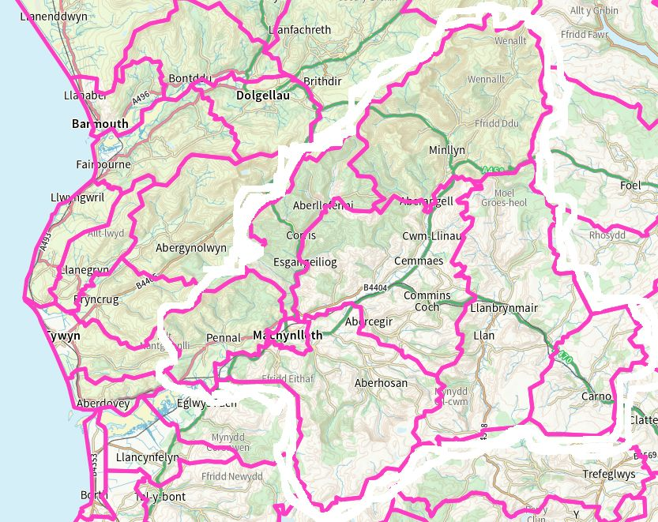

3. Background
The project proposal was developed by Machynlleth Enterprise Forum into a Community Renewal Fund funding application. Ecodyfi agered to act as the ‘responsible body’ for the evolving local network called ‘Dyfodol Dyfi’ from June to mid November 2022, so the area could access the 2022 grant from the UK Government’s Community Renewal Fund through Powys County Council and the Powys Association of Voluntary Organisations.
It was important for it to a co-created with the community project so steering Group was disbanded and a new oversight group formed which sought to have representation from every community council in the Dyfi Valley, Town and County Council, a wide range of organisations in the area including third sector and also individuals who worked with and for community. In addition all meetings were open to the public to attend.
During the past 5-10 years there have been several projects in the Bro Ddyfi area consulting with communities about needs, undertaking surveys, discussing development of project ideas. From these have emerged many valid ideas however the lack of movement into anything tangible, further heightened by the delays caused by the Covid Pandemic have left many people feeling dis -incentivised to engage with community development projects. With this in mind we were committed to revisiting all these engagement exercises, refreshing the needs expressed, reevaluating them in light of local, national and world changes and ensuring that these were fed into and built upon within the Dyfodol Dyfi project.

A Machynlleth ‘Town Regeneration Investment Plan’ (see Appendix 13) was commissioned by Powys County Council, and the consultants worked this up during roughly the same period as the Dyfodol Dyfi funded project. They liaised with key stakeholders and ourselves, but not with people from the wider Bro Ddyfi area. That Plan should be read alongside this document, noting that it had a narrower focus on the economy and potential investments, in the immediate Machynlleth area. It is hoped that the TRIP will prepare the way to accessing Welsh Government’s ‘Transforming Towns’ funding stream and other public sector funding.

4. Dyfodol Dyfi Project (June – November 2022) - What happened?
4a. Approach
The project proposed the following outcomes;
• People feel more involved in discussing the future of their area.
• People can see ways to help steer change in positive directions.
• People are more used to listening to the views of people not in their immediate community.
• A community development plan – a living document to inspire and guide developments
• Documented evidence of need that is being used to support the case for subsequent support, including from the Shared Prosperity Fund.
• A forum, network or mechanism to continue the collaborations and to help bring about improvements that will make a real difference to people’s quality of life and community well-being.
• Several specific proposals have been progressed or carried out.

In order to achieve these aims it created the following aims to steer the project process;
• With the people co-create an inclusive, engagement process leading to a draft community plan with an established, engaged and pro- active network to deliver it,
• Plans for the future,
• Deliver a few “quick wins” project so that community can see success not just talking shops,
• Dig deeper and reach further to engage those who traditionally resist involvement in community engagement and surveys,
• To explore why some areas of community traditionally resist engagement in projects like this and develop ways to achieve engagement in previously unsuccessful groups/demographics,
• A learn by doing and test and pilot approach, deliver along lines of previous successes in engagement but test and pilot other styles of activity to achieve that deeper reach,
• A skills development approach for wellbeing, fun, life, work in activity – gathering people to learn a new skill, have a go at something not tried before,
• To embed evaluation of its process within the project to ensure learning is gathered and shared on what has worked and what hasn’t and to redevelop,
• To use conversation facilitators at activities to host community conversations,
• To develop a series of questions – through a process of community conversation generators, let people talk and learn about what is of interest to them, share stories, listen to stories,
• To hire cafes, businesses to host community conversations directly putting money back into local economy,
4b. Past and Current Projects
The following section maps and summaries past and currently active projects which identified unmet needs. Many of these needs are still unmet. Some of these projects are ongoing. The full reports and surveys are available as appendices to this document.
- Rural Futures’ action-planning report ‘Bro Glantwymyn’;
This 2018 project was funded by National Lottery to make good things happen in rural communities in Wales. The project gathered community conversations through a mobile story studio which visited villages. 4 key priorities emerged; Community cohesion, local economy and employment, Access to Services and amenities and future for Young people. The voices of people gathered collectively talk about the loss of service and amenities in villages and the importance of those central spaces to gather, buy, collect, share and support one another. There is much in this report which gives evidence of need for community hwbs and is strong in voicing the challenges of rural living. The project was stalled due to covid however is active again and supporting the Cwmllinau development as well as continuing to work in other rural areas.
- The ‘Making a Difference’ community survey that led to the Trywydd Iach – Outdoor Health project, and the Trywydd Iach School Survey report dated July 2021;
The Trywydd Iach project is currently active delivering against the evidence of needs identified in the survey.
- Machynlleth Climate Action’s action planning process aligned to Machynlleth Town Council’s Declaration of a Climate Emergency;
Machynlleth Town Council was the first Town Council to declare a climate emergency. This action plan is an ongoing commitment to make changes to address the climate emergency, some actions have been taken however this report does identify significant areas which could be addressed for the benefit of the communities.
- The Dyfi Biosphere’s business and development process;
This business and development process offers information and evidence of needs which are currently being undertaken,
- Tir Canol’s (previously called Summit to Sea) co-designed Blueprint
Tir Canol is a project developing ideas for collaboratively improving the area for people and nature in the face of reducing biodiversity and major ecological and climate problems at local, National, and International levels. The project is focused between the rivers Dyfi and Rheidol overlapping with Dyfodol Dyfi and the Dyfi Biosphere. The project explored extensively a community co-creative process and developed a number of ideas for projects relating to Land & Sea, Human Connections, Research Development and Shared Learning. The Blueprint is an invaluable resource for models of co-creation and projects relating to nature, wildlife, landscape, farming and environment for future generations.
- Re-use of The Old Stables (Machynlleth);
The Stables Hen Stablau is a project to re-use the Old Stables which are part of Y Plas (owned and managed by Machynlleth Town Council. It has initial funding from the Architectural fund to scope the project. The project benefited from the expertise of Falzon associates -taking the lead to advise and steer the project for Machynlleth Town Council (Falzon Associates were part of the team which successfully purchased and developed the Cletwr community cafe and shop). Following surveys and consultation the decision was taken to develop the space as bunkhouse style accommodation to service the need in the area for cheaper holiday accommodation whilst also providing community space at low cost.
- Community/business use of the Natural Resources Wales site at Heulfryn, Esgairgeiliog;
There has been on ongoing negotiation for the site to be used by community which the most recent discussions have confirmed however final confirmation from NRW has not been delivered though it is believed to be imminent.
- A more suitable shared space at the entrance area at Y Plas;
Mach Fringe have been consulting with community ideas to improve the entrance to the community Hall at Y Plas to make it more accessible and welcoming and further its use as a community space.
- A new building for Machynlleth Community Children’s Project;
The Machynlleth Community Children’s Project is in desperate need of a new building to provide early years childcare provision. Their current building has only a few years left before it will no longer be fit for purpose. The building is also at full capacity and with changes in government regulations happening soon alongside a severe shortage of childcare across the Bro Dyfi area which could position them to increase their figures then a larger building is vital to the area. Its recent application for funding of a new building included plans for a new build and included a community space to provide a family centre and an extension of the service to include family focused community activity. The MCCP project has recently updated its trustee membership and is preparing to submit a third application for funding.
- Development of Canolfan Owain Glyndŵr;
The centre is currently working on its third application to the Heritage Lottery Fund for vital maintenance and repair of the building, making the building more usable and accessible as a community space. It currently houses some local business. It is home to the new Ieuenctid Machynlleth Youth project providing a regular youth club and youth activities in the area.
- Development of village halls/hubs, including Cwmlline, Derwenlas and Aberhosan, and of proposals for meeting spaces where no Hall exists e.g. Penegoes, Darowen.
-Llanbrynmair, A walking route along the A470 from the Tafolwern to Dolfach turning (similar to that from Penegoes to Machynlleth) to reduce car use, provide a safe way to shop / school and encourage exercise; Replacement of playground equipment; Create an exercise event in the community pitch including a cycle track / run around the pitch, football pitch and a five-track 'bike track'.
-Penegoes, Chapel space is empty, community would like to adapt it for community space.
-Cemmaes, Development of the community centre to include more space for childcare,
-Darowen, The development of the Eglwys Sant Tudor to provide a community space for events and activities.
-Derwenlas, Community hall needs some development, project to explore kitchen and bunkhouse accommodation. Potential wedding venue working with local pub,
-Pennal, The community purchase of the local pub to provide a community pub, shop and community space,
-Ceinws, Ongoing discussion to use the Natural Resources Wales site at Heulfryn, Esgairgeiliog, NRW are currently in discussion to open it for EOI’s with a Community use stipulation, it is anticpated that this will be announced by December,
-Cwmlline, The community Centre is currently having architects plan drawn for improvements with an energy efficiency focus.
There are additional proposals for development of existing community spaces and purchase and development of a number of chapels and churches in the Bro Dyfi area. A number of these are under threat due of closure or have been closed and are falling derelict. They have been under discussion or await community momentum to progress them,
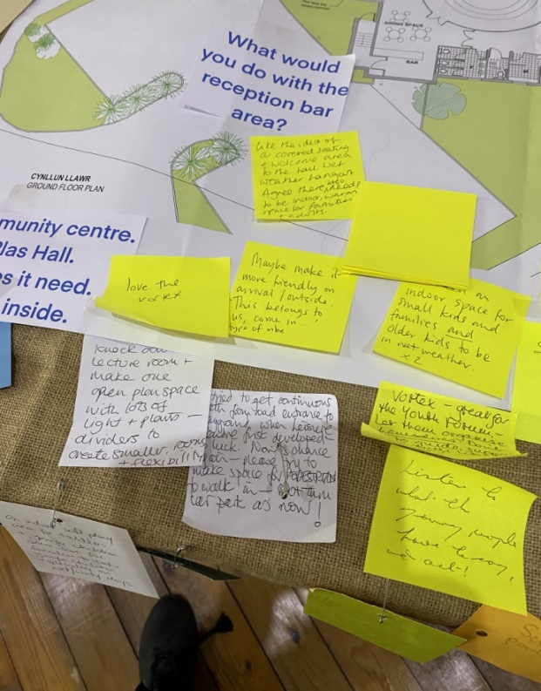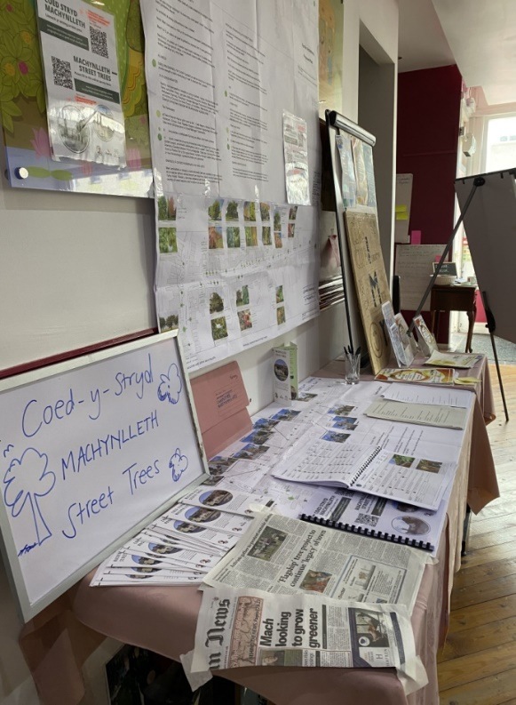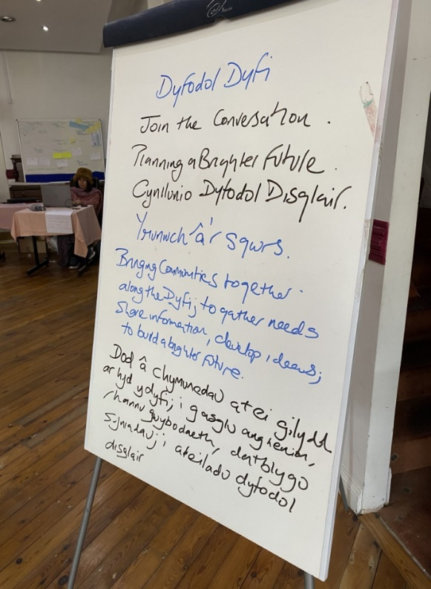
4c. Pop Up Shop.
The project secured the use of 21 Heol Penrallt (the empty former Taj Mahal), for eight days. The Pop Up Shop aimed to celebrate the community through allowing the many projects, organisations and groups in the area to share information, learn about similar work being undertaken, identify cross pollination potential, develop ideas for future shared working. The shop asked communities to Join the Conversation.
It developed an idea of creative visioning offering a space, facilitators and tools, for communities to gather and discuss themes, ideas, needs in the area and form ideas of how the area could be improved.
Activities included,
- Green Spaces – a mapping of growing projects, ideas for use of growing spaces,
- The patients forum hosted a discussion about the Bro Dyfi Community Hospital proposal,
- Community Hwbs – a discussion of a vision for a community hwb,
- Visual recording artists illustrated the needs.
- Storytelling – tales of the Dyfi, crankie making workshops, creating a sense of place and connecting through story,
- DX3 – local radio station pilot,
- Upcycling sewing machine workshops,
- Tir Canol’s Blueprint
- Hen Stablau consultation
- Street Tree Project consultation
- Mach Maethlon Allotment Survey
- Eginiad Well Being Survey
- Tyfi Dyfi survey of local food needs,
- Local illustrators and animators responding to the shop and delivering workshops,
Over 250 people visited the shop through the week.
With many people dropping into the high street space out of curiosity as well as coming along for the various activities the footfall into the shop had a wide demographic that reached beyond people who usually engage with consultations of this nature or participate in community activity.
The Pop Up Shop was successful in bringing groups together to raise awareness of one another’s work. It proved the need of a community space to generate ideas, support, a sense of cohesiveness. It also proved the value of a co-creative approach with community, of empowering community to express their needs and the importance of creating inclusive community spaces.
For events that took place after the Pop Up Shop there was an ongoing process of sharing what was developed within the space with wider communities inviting more people to Join the Conversation. Effectively inviting the wider communities of the locality to continue the process of co-creation.
The pop up shop in its brief existence across eight days showed the value of a community hwb to provide multiple positive impacts within communities.
The comments and thoughts have also been collated here https://app.clusta.live/DyfodolDyfi

4d. Meetings of the Dyfodol Dyfi group
Following the Machynlleth Enterprise Forum meeting on 10th March 2022, the Dyfodol Dyfi group met frequently to discuss project progress and emerging conversations and needs. Meetings were either face-to-face or ‘hybrid’ meetings. Minutes are available from Ecodyfi on request.
Pre-project period: 31st March, 13th April, 4th May
Funded project period: 13th June, 13th July, 27th July, 17th August, 18th September, 17th November
The group selected Cllrs Elwyn Vaughan and Ann MacGarry as Co-chairs .
The full membership is listed in the Appendice.

4e. Other Events and Activities
- Individual meetings with stakeholders, steering groups, representatives of organisations, individuals including; Mach Fringe, CAMAD, Sioned Pritchard (Community Connector, PAVO), Owain Glyndŵr,
- Stand at Machynlleth Carnival
- Tyfu Dyfi Ffair Haf
- Egwlys Sant Tudur Open Day
- Agricultural Shows – Llanbrynmair, Dinas Mawddwy, Pennal
- Survey – Online and Paper (over 50 responses which are included in the appendice)
- Repair and Share Day - Y Plas Machynlleth
- Open Day at Bowling Club – Machynlleth
- Open Day at Glantwymyn Community Centre

4f. Quick Wins
Eglwys Sant Tudur
Dyfodol Dyfi provided support to this project which was seeking to save the church and convert a section of it into a community space for the use of Darowen and surrounding villages. The Quick Wins section of the project awarded money to provide architectural drawings to help them secure funding for the project. In addition a community noticeboard was created.
Canolfan Glantwymyn
Dyfodol Dyfi provided support to this project which was seeking an extension to increase the capacity of the Cylch Meithrin at the centre. The Quick Wins section of the project awarded money to provide architectural drawings to help them secure funding for the project.
Ieuenctid Machynlleth Youth
Dyfodol Dyfi provided support to this project to help them administer the project to begin operating ahead of securing funding for longer term resource to support the project. The Quick Wins section of the project awarded money which was administered by Stiwdio Dyfi on behalf of the newly-formed unconstituted group.
Mach Fringe
Dyfodol Dyfi provided support to this project in terms of advice on gathering evidence of need, strategic advice on developing this type of project and funding advice. The group applied directly for a CRF grant to cover architectural fees for drawings to help the progress the project and secure funding.
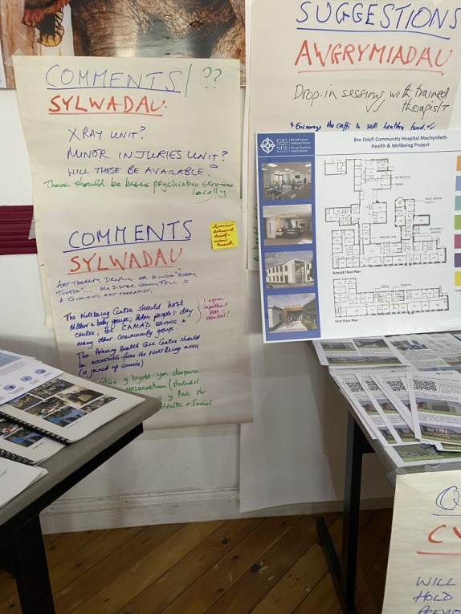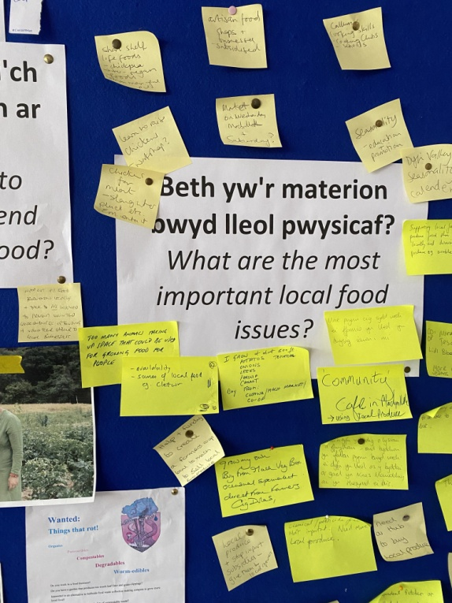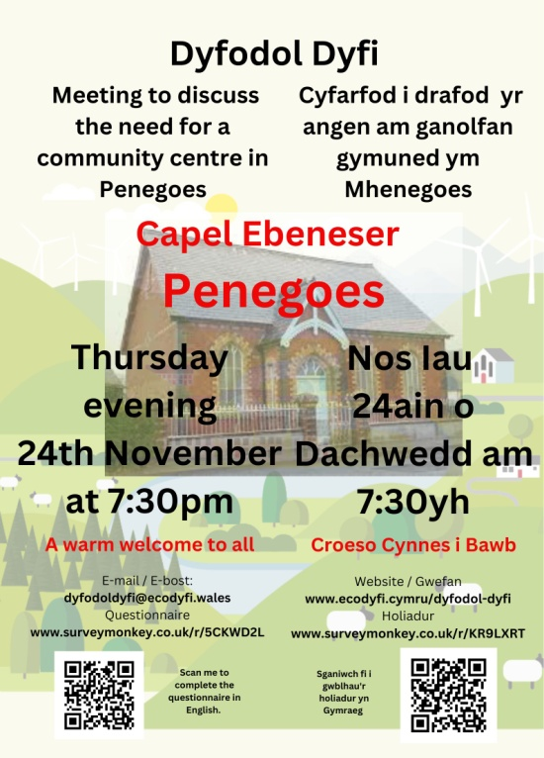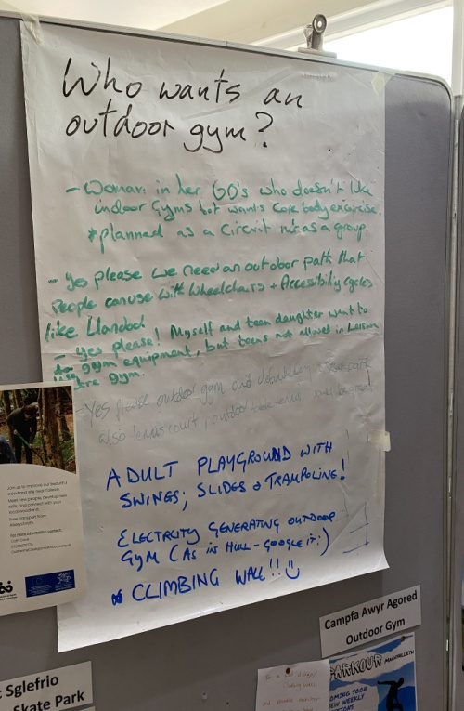
5. Summary of Potential Actions
Dyfodol Dyfi has identified a number of potential themes which could be used to further discussions or to provide narrative and structural depth to funding applications. The project has tried to interpret the responses from the public as openly as possible to allow the widest potential use of the project’s output in the future.
The following themes have emerged from the project, as detailed in the Table below:
A) Connecting Communities and Connecting people to their Community
B) Supporting Local Economies
C) Supporting the needs of the area in terms of nature, wildlife, landscape, farming and environment for future generations
D) Access to Fundamental Amenities, Resources and Services
E) Improving Communications, Empowering Voices, Listening Spaces, Being Heard,
F) Health and Well Being
G) Welsh language

6. Table of Expressed Needs and Potential Actions
The table has been designed to allow impacts and aims to be aligned against the actions according to the specific purpose, needs, provision being discussed. Accordingly we have not cross referenced or aligned impacts to each specific action.

The actions table is divided into AIMS, ACTIONS, IMPACT - potential actions are ideas co-created with community prompted by needs identified.

WHO – The WHO column identifies organisations currently working in or developing projects in the area and could lead on or partner with others to deliver the activity.

It should be noted that actions could be taken forward by statutory bodies; Town Council, Powys and Gwynedd Council, Community Councils if funding was available. The action could also be taken forward by statutory bodies in partnership with third sector organisations or third sector organisations could seek funding to take actions forward.

In a few cases specific organisations are named as they are strongly associated with this work or considered experts. We have also identified community groups who could lead or be a partner on these projects.

THEME | AIMS | POTENTIAL ACTIONS |  | IMPACT | WHO
THEME A) Connecting Communities and Connecting people to their Community
 | A1. Creating Community Hwbs in villages,  A2. Connecting community hwbs to one another to share resources, and create an interconnected hwb across the locality  A3. Create roles which can support community connection  A4. Create sustainable business plans for community hubs, village halls, community spaces,  A5. Access to, access from, access into, community spaces, getting to and from community spaces and making community spaces accessible in terms of facilities, entrances and equipment, in the wider sense of accessibility as well as in terms of disability, making spaces inclusive,  A6. Making area attractive to live in and for visitors,  A7. Creating a sense of belonging and pride in environment,  A8. Celebrating the joys and benefits of living in the Dyfi Valley through community events and gathering which celebrate culture, heritage, landscape of area.  A9. Empowering community groups to support community managed land and assets schemes for housing, growing, business, biodiversity, health and well being,  A10. Creating spaces for communities to co-create plans to lead to co-ownership of problems and solutions,  A11. Giving communities toolkits, skills and models to co-create projects, | Mapping the hwbs, needs of repair and maintenance, identifying ways in which they could share resources, establishing long term plans for sustainable planning for repairs and maintenance.  Creating interconnected Community Hwbs in villages - creating a Bro Dyfi Community Hwb strengthened through size as a mult-location community hwb whilst serving hyper local needs,  Providing resource of local officer(s), (support roles or coordinators), connecting them more effectively with one other, creating business plans to make them more resilient and self sustainable, creating a programme of events such as classes, talks, films, performances touring through the village halls, developing equipment packs that could service all the halls, fundraising, sharing expertise throughout the villages, creating a distribution network throughout the villages which could support local economies, managing the hire, loan and use of the halls on behalf of the community, making commercial options more viable, hire for functions, accommodation, hybrid spaces, creating incubators of small local business, allowing networks hyperlocally, locally and across the county,  Projects to share expertise and knowledge from local community development projects like Cletwr, Pennal to others considering developing community hwbs, spaces, amenities, alongside sharing knowledge learning and experience this sharing of information could inspire others to become more active as the feel supported.  Provision of better transport systems between villages and into towns through public transport (services that were dropped during covid re-instated), better community transport scheme (Bus and car services, shared car and bus systems), integrated transport systems,  Creating or recreating Pathways & Cycle routes between villages  Projects offering Health and Well support within community spaces, workshops, social prescribing, information  Heritage projects within communities focusing on heritage of area – farming, industrial, social, history, legend, stories, music, culture, language,  Projects supporting ways to empower voices to ask for what is needed, and have agency in changes, allowing all voices to be heard and have ownership of changes.  Projects to continue co-creation processes, working to widen demographic and build relationships and trust over a longer timeframe, an ongoing and ever widening process, |  | Create Cohesive Communities  Creating spaces for young people to thrive and choose to stay or return to their communities  More knowledgeable communities taking ownership of and managing,  Empowering voices to ask for what is needed, and have agency in changes, allowing all voices to be heard and have ownership of changes.  Communities supporting local economies,  Communities supporting one another,  Communities achieving their aspirations, inspiring others,  Helping communities to level up with one another in facilities and amenities,  Creating spaces for community to gather, creating spaces that communities, groups, organisations, business and individuals can use,  Accessible community spaces both indoors and outdoors,  More people accessing community spaces both indoors and outdoors,  Better Health and Well Being,  More people spending on local economy,  Creation of jobs within community transport networks,  Making community transport schemes more viable as they work across larger area,  More people engage in local, community and regional council and groups and organisations, more people getting active in policy making,  Better Health and Well being through having agency and ownership, | Village Hall / Community Centre Committees  Tŷ Cemaes  Canolfan Pennal  PAVO  Dyfodol Dyfi  Ecodyfi  Current project ‘Trywydd Iach’  Proposed project ‘Hwb’
THEME B) Supporting Local Economies
 | B1. Create and connect local economies and expertise,  B2. Create and connect tourism businesses and local businesses,  B3. Develop, strengthen and support renewable energy expertise,  B4. Create a sense of belonging and pride in Bro Dyfi,  B5. Creating better tourism packages which focus on local strengths  B6. Raising awareness of different economies, circular, landbased, rural, greener,  B7. Creating environments in which local economies can thrive and create opportunities,  B8. Support for local businesses starting up,  B9. Support for businesses to increase capacity,  B10. Support for businesses to diversify,  B11. Create networking opportunities for business that are inclusive and accessible for all,  B12. Creating Skills development opportunities across all local industries,  B13. Creating more effective networks to support innovative small to medium size businesses, with statutory bodies, training providers, third sector, community groups and organisations, | Projects raising awareness and strengthening local economies including promoting the ideals of circular, land based rural and greener economies. Including indoor markets, regular farmers market, shared shop premises food festival, food hwb for local produce, independent butcher and baker,  Projects to raise awareness of buy local – schemes supporting local business, creating sense of supporting community by buying local,  Projects to promote local business and local expertise, success stories,  Projects to support night-time economy in area,  Projects to improve the town and make it look more attractive; hanging baskets, pavements accessible, street trees, signage, better management of road parking, better management of traffic, accessibility for pedestrians, benches which mean that people with mobility issues could walk from top of town to centre of town on market day, then linking these with projects to improve cycle and walking routes from town to community hwbs, hedges better manages, walking routes cleared,  Projects to provide public transport including community run services which make it possible for rural locations to be serviced regularly which bring more people to town and out to village hwbs and activities,  Projects to support local distribution of goods throughout area to deal with rural access to local goods,  Projects to create activities – festivals, out of season festivals, more celebration events which engage those who live and visit the area and bring footfall to area,  Projects to promote and provide tourism support such as local campsites, cheaper accommodation (bunkhouses), tourist information, signage, information boards,  Projects to develop empty spaces for premises for business development,  Skills and Training provision – in areas suitable to local economies, heritage and rural crafts, business, marketing, renewable energies, active tourism,  Skills and Training provision in Entrepreneurial and Self Employment,  Projects to create social enterprise hubs which operate as incubators to generate opportunities, networking, support frameworks which are vital in rural economic development,  Projects to raise awareness of existing pathways to skills development and development of business,  Projects to create mentoring and apprenticeship schemes,  Projects to develop better volunteer support and encourage recruitment - supporting increase in volunteers – training, development of programmes, volunteering as a way to increase skills and as a pathway to employment,  Creating Brodyfi tourism packages focusing on innovation and expertise in area, renewable energy, climate awareness, sustainability, adventure, heritage, culture ,– the expertise and uniqueness of area combined into sellable tourism packages,  Project to align various projects looking at other forms of currency – exchange, upcycle, recycle, sharing, drawing the projects into one to create a more efficient method of exchange, upcycle, sharing - https://www.pavo.org.uk/help-for-organisations/amser-i-ni-time-for-us.html  Projects which connect routes, pathways journeys between points to encourage visitors and those who live in Bro Dyfi to travel from and to places by cycle, community bws, creating information boards, embedded technology, amenities along these routes which get people out, visiting, to and from places, |  | More Opportunities in the Area  Spaces for young people to thrive  Creating more industry, more employment, more self employment,  More skills in heritage and rural crafts.  Healthier local economies; circular, land based -rural, greener,  Healthier year round and night-time/daytime economies  Healthier tourism trade including off season,  Better balance between supporting those who live and those who visit area,  Make it possible to walk or cycle around town and to villages throughout the Brodyfi area,  More localisations of supply chains,  Resource managers able to access right type of labour locally,  More private/public sector collaborations creating community benefit together, | Machynlleth Enterprise Forum  Dyfi Biosphere, including the Tourism Association and the Blas Dyfi Taste branding  Ecodyfi  Menter a Busnes  Current project Tyfu Dyfi including Bwyd Dyfi Hub  Dulas, Cambridge Sola, Dyfi Bike Park, Atherton Bikes, building companies,  Tai Dyfi,
THEME C) Supporting the needs of the area in terms of nature, wildlife, landscape, farming and environment for future generations
 | C1. Increasing access to nature and wildlife  Protecting and supporting local nature and wildlife,  C2. Stopping loss of biodiversity,  C3. Improve food surplus management,  C4. Better local waste management including local community composting,  C5. Raise awareness of how the land and sea is managed,  C6. Reconnect people with the resources that sustain them,  C7. Sharing the stories of our nature, our wildlife, our landscape, our farming and our environment, | Projects to raise awareness of issues in area impacting on nature and biodiversity, landscape and environment to connect people to the area,  Projects to develop skills in nature, wildlife, landscape and environment,  Projects to support biodiversity and ecosystem services, to support the people and businesses that manage and use natural resources,  Projects to raise awareness and use the expertise in the area in nature and biodiversity, landscape and environment, to develop opportunities, groups, organisations and business.  Projects to underpin the organic, sustainable, regeneration growing groups/organisations/farmers in the area, raising awareness, addressing climate justice, engaging and empowering people to connect to nature, wildlife, landscape and environment  Projects to develop training in rural crafts and trades such as dry stonewalling, hedging, spinning, weaving, clothes making, shepherding,  Projects to develop and strengthen existing growing projects providing more space for community growing of edibles, more space for allotments, raising awareness of seasonal growing and buying, workshops for growing own food in small and shared spaces,  Projects progressing Machynlleth Town Council’s action plan and Wellbeing of Future Generations Act.  Projects exploring and initiating Climate Justice in Bro Dyfi.  Supporting businesses, traders, enterprise and organisations to do more for local wildlife, |  | Connecting people to climate emergency through reconnecting with nature, wildlife, landscape and environment,  Wider knowledge of biodiversity, local landscapes,  Wider knowledge of Welsh words for nature and wildlife,  Creating an environment in which people want to live, work, play, learn,  Healthier landscapes, rivers with healthier ecosystems, decarbonisation,  Building traditional and nature positive skills locally,  Shared ownership of local land issues between public, private and third sector,  Empowerment of local people and collective ambition to work together to address local and global issues affecting nature, wildlife, landscape, farming and environment, | Dyfi Biosphere, Tyfu Dyfi, Dyfi Biodiversity group, Town Council (Machynlleth Climate Action Plan), Tir Canol & partners (RSPB, Coed Cadw, Tir Coed), Coed Lleol, Llais y Coed, CAT, NRW,  Mach Maethlon,  Farmers Union, Local colleges, Young Farmers, New Dovey Fishery Association  Arbed Bwyd Machynlleth Food Surplus  Facebook group @NaturDyfi  Coetir Anian
THEME D) Access to Fundamental Amenities, Resources and Services
 | D1. Make communities more aware of existing help that is available,  D2. Strengthen provision of fundamental amenities, resources and services with a particular focus on those that are more difficult to access due to rural location,  D3. Improve sports and activity facilities including outdoor gyms, skate parks,  D4. Support community kitchen and community fridge, | Help for impact on cost of living crisis including clear signposting for help and support, transparency of organisations, information sharing regularly – working with PAVO, Advice Mid Wales, CAMAD, Third Sector organisations,  Projects to create a community fridge, community kitchen, cooking workshops, food surplus and food waste initiatives,  Networking opportunities for third sector organisations with statutory bodies eg Community Connector events, drop in sessions,  Clearer communications of third sector and statutory organisations and bodies which ensure signposting of available help,  Access to free and cheap food, access to warmth, access to skills development, access to IT equipment, access across languages and abilities,  Projects to raise awareness of Health and Well Being Initiatives,  Projects to make capital purchases of equipment that can be used across Bro Dyfi in community spaces and shared to make Bro Dyfi communities better equipped  Projects to develop better volunteer support and encourage recruitment - supporting increase in volunteers – training, development of programmes,  Projects to improve town centre and villages and community spaces, make pathways accessible, provide routes to walk round town and from village to outdoor spaces, provide sensory play parks, provide outdoor gyms, provide play equipment,  Projects to give young people access and support for activities they have requested in surveys such as woodland skills, outdoor gym, wild swimming, skateboarding, dirt jumps, dirt biking, DIY skills, cookery, donkeys,  More childcare provision, | Better health and wealth being,  Impacting on poverty,  More people able to access help when it is needed before reaches poverty levels and to help out of poverty,  Less opportunity to drop through gaps, more opportunity to access help,  Better community infrastructure,  Improve the built environment,  Better accessibility for disability,  More volunteers, |  | PAVO, Advice Mid Wales, CAMAD  Arbed Bwyd Machynlleth Food Surplus  Mach Maethlon / Edible Mach  Ieuenctid Machynlleth Youth
THEME E) Improving Communications, Empowering Voices, Listening Spaces, Being Heard,
 | E1. Creating communities who can get the information they need about events and activities,  E2. Creating communities who want to speak up who want to listen,  E3. Creating spaces for unheard voices,  E4. Celebrate the area’s identity, successes, community spirit, | Create a marketing and communications group for Bro Dyfi (sub group from Dyfodol Dyfi) which can progress initiatives already proposed such as proposal from Glasbrint attached in appendices.  Providing tools, expertise, skills training and resource to better manage communications in the Dyfi locality,  Producing a printed diary of events and activities across the Bro Dyfi,  Projects to streamline how communications are shared in the area, creating a one stop shop for promotion which feeds our promotion across multiple platforms including print and noticeboards,  Projects to continue community engagement – creating spaces to co-create a vision of the community for the future, ensuring ongoing process across longer term to allow wider demographics, addressing issues of mistrust from sectors of community through allowing them a space and a place to speak and be heard, developing skills of community engagement and empowering voices who feel community engagement is not for them, creating spaces for people to speak in the language they wish to speak in (language – speaking/writing or drawing, or transcribed or recorded conversation or film),  Projects to communicate what is happening, sharing stories of good in community, celebrating community, ensuring people know what is happening in their community, who is doing what, stories to inspire, stories to make people proud of community and connect to community, |  | Improving awareness of activity to avoid repetition and risk of gaps in provision.  More people attending events,  More people active in groups and organisations,  Stronger sense of living in a vibrant and active community with lots happening,  More people able to make viable income from events and activities,  More people knowing where to go for help, support, learning, skills, training,  More events happening, more active diary of events,  More vibrant evening economy,  More vibrant place to live and visit,  More participation in community events by visitors, | Organisations currently working in the area who could potentially take forward these projects;  Town Council, County Council, PAVO, Community Councils  Stwdio Dyfi developing idea of printed Diary of events, Glasbrint proposal for maps/guides,
THEME F) Health and Well Being
 | F1 Develop a more sustainable and long term approach to supporting and delivering health and well being,  F2 Address structural and behavioural barriers to active travel  F3. To make green spaces more accessible,  F4 Maximise community involvement in shaping, delivering and using services at the re-developed Bro Ddyfi hospital and well being centre,  F5. Further develop social and green prescribing  F6 Increase access to therapeutic activities and services, | Projects to provide resources to connect patients/users needs to local, regional and national health provision,  Projects to support patients to better manage their own health ,  Projects to allow people to have more ownership and control on their health management empowering them to know how to get help, who to speak to, how to complain their own health management and their access to health provision,  Create a Health Care Community Development worker, and capital for equipment such as computers, monitors and audio-visual equipment that can enable people to access reliable health care information, both as individuals and in groups. The job description would include working with the Community Connector, CAMAD and health related voluntary groups to increase their capacity and to widen participation. It would include organising activities around health issues, with advice and where possible participation by clinicians at Bronglais and in Primary Care and expertise available outside the region through telecommunication.  An increase in organised voluntary organisation around health and welfare, and in the level of information for the public on health matters - information that is accessible and reliable, and not dependent on attendance at surgeries and clinics. The new development at Bro Ddyfi Community Hospital provides a real opportunity for an imaginative and innovative development if it could realising the full potential of the new development in supporting the community through co-creative with the community of the facilities.  Bring collaborative social and green prescribing into mainstream health provision so as to provide continuity, confidence and strong referral mechanisms, |  | Better health and well being  A stronger sense of ownership of ones health and well being,  Increase in cycling and walking  More participation in outdoor health initiatives, | Patients Forum, Bro Ddyfi Health, Powys Teaching Health Board, PAVO, CAMAD,  Eginiad, independent therapists and outdoor activity leaders,  Trwydd Iach project, Coed Lleol, ecodyfi  Ysgol Bro Hyddgen,
THEME G Welsh Language – this is fundamental and underpins all themes
 | G1 More Welsh speakers staying in their communities and/or returning to them after higher education or later in life  G2. Welsh speakers using Welsh in more situations, more often  G3. More adults learning and using Welsh,  G4. Reduce separations between welsh speaking and non welsh speaking communities | Better provision of employment and self employment opportunities, housing and services  Help family farms adapt to changing policies and markets,  Community hwbs providing Welsh language classes for beginners and intermediate  Informal practice conversations of Welsh language for beginners, intermediate and business specific  Projects to raise awareness of heritage and its connection to language – importance to economy, region and opportunities,  Projects to increase provision of high quality Welsh language child care, |  | Increase of numbers of Welsh language speakers staying in the area  Increase in people learning Welsh,  Increase in people feeling confident to speak in Welsh and declare themselves a Welsh speaker  Improved community cohesion, | Siop Siarad, Canolfan Owain Glyndŵr, Mudiad Ysgolion Meithrin, Menter Maldwyn, Ysgol Bro Hyddgen,  Dysgu Cymraeg, Ceredigion – Powys Sir Gar

7. Wider Evidence of Issues and needs
The 2021 census has revealed;
Powys has the least population density – (using a scale of football pitches, five pitches per resident in comparison to Cardiff the most population dense area of Wales which has about 18 people per football pitch).
The population has continued to age. Across Wales, more than one in five people (21.3%) were aged 65 years and over on Census Day in 2021. This is a higher percentage than ever before. This is how Powys compares. There has been an increase of 22.3% in people aged 65 years and over, a decrease of 5.8% in people aged 15 to 64 years, and a decrease of 9.3% in children aged under 15 years.
The recent round of funding from the Social Value Forum highlighted the following gaps that have been identified by PAVO Community Connectors and Statutory Services which were prioritised (but not limited to);
- The provision of good neighbour schemes offering low level, practical help to people. (Collaboration with Amser i Ni time banking initiative is encouraged)
- Strengthening the provision of community transport, with a particular focus on transport for young people and people that live with disabilities.
- The provision of befriending services for young people.
- The maximisation and encouragement of intergenerational provision where appropriate.
The aim of the Social Value Development Fund is to fund new or to extend existing social value sector preventative services and activities that fill and bridge gaps in current provision that improve mental and physical well-being, help individuals to live an independent life with the aim of reducing the need for higher level intervention. The funding has been made available from the Powys Regional Partnership Board via the Social Value Forum.
This funding will continue in 2023 however it is very limited with a fund of just £40,000 it is difficult to see how it can keep up with the inevitable increased gaps in needs
A number of recent projects, feasibility studies and surveys identified needs in the area. Dyfodol Dyfi engagement has found that those needs are still unmet and have been amplified by the Covid pandemic and the cost of living crisis. Services, resources, equipment previously delivered at county, national Wales and national UK government level have all been further discontinued, depleted or become derelict. The recent census has identified further areas of concern across Powys and Gwynedd indicating a rising, aging population alongside a depleted number of younger people staying in the area. Rural isolation and poverty will only increase in the current economic climate. Fundamental needs can only be met through community support through local charitable and not for profit organisations fulfilling and supplying services, resources and equipment. Empowering communities to provide fundamental needs within their own communities is vital as we face the ongoing crisis of economy causing food and fuel poverty and the ongoing crisis of climate impacting on loss of language, biodiversity, nature and wildlife. Connecting communities hyper-locally and locally, to support them to be successful in funding applications and empowering them to provide these needs, is the starting point to any community driven initiatives.
The Dyfi Valley offers many examples of connected communities delivering inspirational projects, however in many ways this serves to highlight those communities without agency and expertise to organise groups, governance, constitution, business development plans and successful funding application. Finding ways to share resource and expertise across these rural areas to deliver a more cohesive, connected community development plan and direct funding to where it is needed most and make those successful projects sustainable and more impactful across a longer period.
It is also an area where innovative small and medium size businesses are establishing themselves and growing and more can be done to create community collaborations and seek wider community benefit especially within longer term initiatives of community working with business for the benefit of all.
Further evidence of issues is listed in the resources at the end of this document.

8. Appendices – all appendices are available to download at https://www.ecodyfi.wales/dyfodol-dyfi
Appendix 1: Rural Futures’ action-planning report ‘Bro Glantwymyn’;
Appendix 2: Trywydd Iach School Survey report dated July 2021
Appendix 3: Machynlleth Climate Action’s action planning July 2019
Appendix 4 The Dyfi Biosphere’s business and development process
Appendix 5 Tir Canol (previously Summit to Sea) ‘s co-designed project ‘Blueprint’
Appendix 6 The Old Stables Project
Appendix 7 Y Plas Entrance Development Survey
Appendix 8 Cwmlline Survey
Appendix 9 Eglwys Sant Tudur Darowen Project Survey
Appendix 10 Bryn y Gog Graffiti Workshop Survey for Iueunctid Machynlleth Youth
Appendix 11 Tyfu Dyfi Report and Survey
Appendix 12 Town Regeneration Investment Plan Survey (TRIP)
Appendix 13 Town Regeneration Investment Plan (TRIP) for Machynlleth - report
Appendix 14 Health Care Community Development Proposal from Patients Forum
Appendix 15 Mach Maethlon Allotment Survey
Appendix 16 Suggestions and comments made to Dyfodol Dyfi, compiled on the ‘Clusta’ platform
Appendix 17 Various evidence of needs including original images
Appendix 18 Join the Conversation Survey
Appendix 19 Membership of the Dyfodol Dyfi Group at November 2022

Useful Resources
Some Key Funding Opportunities
UK Shared Prosperity Fund
https://www.gov.uk/government/publications/uk-shared-prosperity-fund-prospectus/uk-shared-prosperity-fund-prospectus
Powys allocation - £22,704,129 with additional increased funds available in 2024 and further increased in 2025.
Currently we have no updates on the UK Shared Prosperity Fund. The main three themes for the funding will be; Communities and Place, Supporting Local Business and People and Skills
The National Lottery Community Fund
https://www.tnlcommunityfund.org.uk/
National Lottery Awards for All £10,000
People and Places – over £10,000 and above
Arts Council Wales
https://arts.wales/
Varying size of grants including Connect & Flourish
The National Lottery Heritage Fund
https://www.heritagefund.org.uk/

Ashley Family Foundation
Community
www.ashleyfamilyfoundation.org.uk
Other Funds
https://funding.cymru/

Examples of recent funding successes in area –
https://www.dyfibiosphere.wales/tyfudyfi
https://www.machmaethlon.org/2021/06/17/mach-maethlon-is-awarded-99952-for-new-food-for-all-project/

The following links give more data about wider issues that could be used in funding applications.
https://www.ons.gov.uk/visualisations/censuspopulationchange/W06000023/
https://www.pavo.org.uk/home.html
https://www.futuregenerations.wales/
https://www.futuregenerations2020.wales/english
https://www.futuregenerations.wales/wp-content/uploads/2019/09/Cohesive-Wales-Topic-3.pdf
https://en.powys.gov.uk/article/5800/Wellbeing-Information-Bank
https://en.powys.gov.uk/article/5801/Wellbeing-Information-Bank-Demographics
https://en.powys.gov.uk/article/11145/Wellbeing-Information-Bank-View-information-about-demographics-by-locality
https://www.sciencedirect.com/science/article/pii/S0743016722001097

Mae’r prosiect hwn yn cael ei ariannu’n rhannol gan Lywodraeth y DU trwy Gronfa Adfywio Cymunedol y DU.
Mae Cronfa Adfywio Cymunedol y DU yn rhaglen Llywodraeth y DU ar gyfer 2021/22. Nod hwn yw cefnogi pobl a chymunedau sydd fwyaf mewn angen ledled y DU i dreialu rhaglenni a dulliau newydd i baratoi ar gyfer Cronfa Ffyniant Gyffredinol y DU. Mae'n buddsoddi mewn sgiliau, cymuned a lleoedd, busnes lleol, a chefnogi pobl i mewn i gyflogaeth. Am ragor o wybodaeth, ewch i https://www.gov.uk/government/publications/uk-community-renewalfund-prospectus

The project Dyfodol Dyfi – Cynllunio dyfodol disglair is part funded by the UK Government through the UK Community Renewal Fund.
The UK Community Renewal Fund is a UK Government programme for 2021/22. This aims to support people and communities most in need across the UK to pilot programmes and new approaches to prepare for the UK Shared Prosperity Fund. It invests in skills, community and place, local business, and supporting people into employment. For more information, visit https://www.gov.uk/government/publications/uk-community-renewal-fund-prospectus

